Identity Manager Web Portal Customization

Paul Sherman

Viloun Viengluang

Updated March 3, 2023

Revision 1

Contents

Summary 5

Prerequisites 6

Prepare Environment 7

1. Build an Environment (Skytap) 7

2. Download and install dev tools 7

Prepare Angular Portal 8

1. Create work environment 8

2. Run Web Portal 13

Working with Web Portal 14

Debug 14

Find component to debug 14

Run in debug mode 17

Modify 19

Deploy to ApiServer 20

Deploy with Software Loader 22

Working with Api Server 23

Executing REST Api methods and viewing data 23

Using Postman to execute Api Server methods 27

Customizations 30

Simple modifications 30

1. Change Top Logo color 30

2. Change Top Logo and main background color 31

3. Change background image 32

4. Change Logo image 33

5. Show additional columns for Dynamic Roles 34

Advanced ApiServer Modifications 36

Build Custom Plugin 36

Create Plugin 36

Run Plugin 40

Test Plugin 41

Deploy Plugin 42

Build Client package (.tgz) 42

Add client package to the Web Portal project 44

Advanced Web Portal Modifications 45

1. Add column 1 – System Entitlements Membership 46

Find module to work on 46

Start debugging 48

Modify 49

Deploy 52

2. Add column 2 – Business Roles Membership 52

Find module to work on 52

Start debugging 53

Modify 54

Deploy 55

3. Add column 3 – User Accounts Membership 55

Find module to work on 56

Start debugging 57

Research ApiServer method 59

Modify 61

Deploy 62

4. Add “Terminate” button 62

Find module to work on 63

Start debugging 64

Modify 64

Deploy 69

5. Add base plugin component 69

Generate a new component 69

Modify Code 74

Debug component 78

Deploy plugin component 79

Deployment errors 80

6. Modify base plugin to display personal data 81

Research 81

Modify 82

Debug 83

Deploy 84

Homework 84

7. Add custom plugin calling custom Api Server plugin 85

Research 85

Build base component 86

Add component displaying data from script 87

Debug 93

Add component displaying data from predefined SQL 93

Debug 98

Moving custom modifications to a new release version 100

Useful Links 101

# Summary

This documentation is a step-by-step guide to getting started with customizing Identity Manager Web Portal. The first release of the new web portal was on Identity Manager 8.2, released December 2021. The new web portal uses the Angular framework that will allow developers to modify the web portal user interface and backend API actions.

The intent of this document is not to teach how to program Angular web applications or to explain how REST API calls work.

# Prerequisites

To work on customizations, it is necessary to have a fully installed and configured Identity Manager installation including API Server and App Server, preferably installed on the development server.

Various development tools and software needs to be installed as well.

**Angular**

Angular is a development platform, built on TypeScript (superset of JavaScript). It is used for building rich web applications. Angular is open-source and comes from Google. Angular is specifically designed to make developing single-page applications (SPAs) easier. Angular also manages cross-browser support automatically.

Angular project consists of:

* HTML templates with Angular markup - for presenting data
* **Component** classes - to manage templates
* **Services** - contain application logic
* **Modules** - logically combining components and services

**TypeScript**

TypeScript is a programming language that’s a superset of JavaScript. TypeScript enhances JavaScript by allowing for static typing and allowing developers to program in more object-oriented ways than are possible with JavaScript. TypeScript is open-source and was developed by Microsoft to better build and maintain large JavaScript programs. The language was made public in 2012 after two years of development at the company.

**NPM – Node Package Manager**

It is an online repository that hosts JavaScript packages

It is a CLI (command-line interface) for interacting with said repository. This utility aids in package installation, version management, and dependency management

Below are some common files that you should be familiar with:

**angular.json**

A file named angular.json at the root level of an Angular workspace contains settings of the Angular project

**package.json**

The package.json file is the heart of an Angular project. It records important metadata about a project which is required before publishing to NPM and defines functional attributes of a project that NPM uses to install dependencies, run scripts, and identify the entry point to our package.

**package-lock.json**

This file describes the exact versions of the dependencies used in an NPM JavaScript project.

**tsconfig.json**

The presence of a tsconfig.json file in a directory indicates that the directory is the root of a TypeScript project. It specifies the root files and the compiler options required to compile the project.

Everything will be pre-installed on our Lab environments.

Prepare Environment

1. Build an Environment (Skytap)

During our lab – create an environment from a template in Skytap. URL will be provided.

Outside of lab – do a complete installation of the Identity Manager. Database can be installed on the same server or anywhere else, but API Server and App Server should be installed on the same machine.

Populate some data to be able to test various modules of web portal and API Server:

* User hierarchy
* Departments
* Business roles
* AD
* Etc.

1. Download and install dev tools
2. [Install Node.js](https://nodejs.org/en/download) Do not select "Current", install LTS.

To check installed version - in command prompt run: npm -v

1. [Download and install Git](https://git-scm.com/)
2. [Download and install VS Code](https://code.visualstudio.com/download)
3. In VS Code install following extensions (a or b) + c:
   1. Angular Language Service, Angular Snippets, html CSS Support, CSS Formatter
   2. Angular Essentials (From John Papa)
   3. Nx Console, GitLens
4. Postman
   1. Import a .json file with sample API requests into Postman.

You can find this file in the distribution folder:

"…\UNITE\2023\UNITE\ApiServer\Identity Manager API Samples.postman_collection.json"

1. Fiddler 4
2. Visual Studio 2019 or 2022

We use Visual Studio to create custom plugins for ApiServer. It is possible to do it in VS Code but requires some changes in setup.

Also, it is possible to do Angular development in Visual Studio, but it will require some configuring projects.

Prepare Angular Portal

Source code is located at:

<https://github.com/oi-nam-presales/IdentityManager-Nam-Presales.Imx>

It is a fork of One Identity main repository.

If connection to GitHub is not available – source code for v9.1 is also distributed in the   
\UNITE\Portal Source Code\ folder.

1. Create work environment

**Clone repository:**

1. In Command Line

* Create a local folder. For example – mkdir C:\Projects\WebPortalV9
* Change to that folder - cd C:\Projects\WebPortalV9
* C:\Projects\WebPortalV9> git init

1. Go to the page

<https://github.com/oi-nam-presales/IdentityManager-Nam-Presales.Imx>.

1. Click on Green "Code" button, copy URL:

<https://github.com/oi-nam-presales/IdentityManager-Nam-Presales.Imx.git>

1. Command Line:

* C:\Projects\WebPortalV9> git clone <https://github.com/oi-nam-presales/IdentityManager-Nam-Presales.Imx.git>

1. Create new branch if **necessary**:  
   For this lab it is unnecessary. The branch is already created: **v91/UNITE/Start**

* In GitHub web site click on Branches button.
* Select New Branch button, give it a name, and select a Branch source.

**Branch source**:

R&D creates a branch per major release of the IM.

Initial code from R&D for version 9 will be in the V90 branch.

We can create a branch per feature or branch per user. We can also create a branch from another branch (source branch) if we want to get all changes from that branch and continue developing on top of that.

Or we don’t have to create a new branch and use existing one.

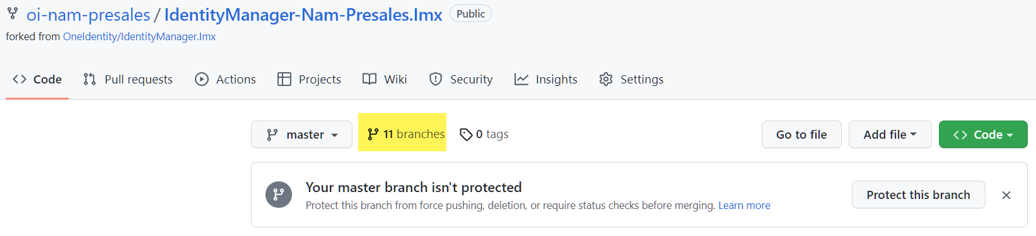

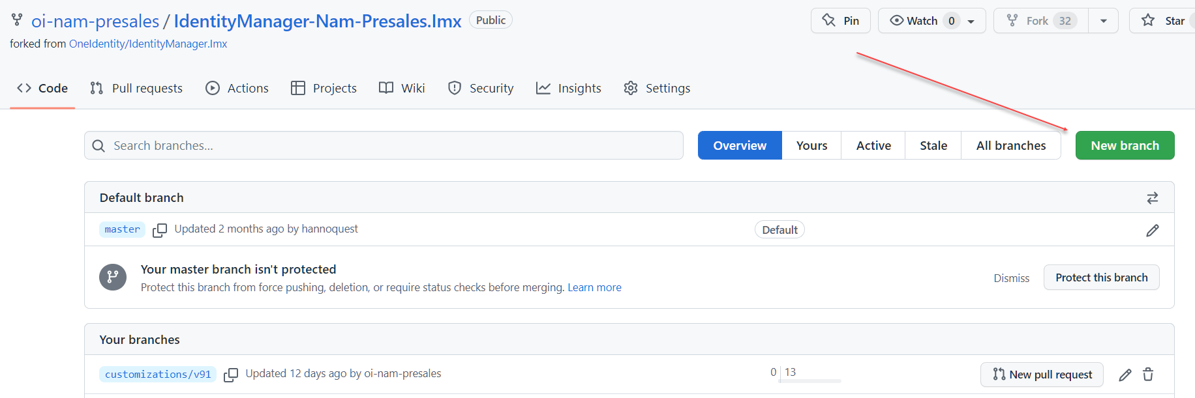

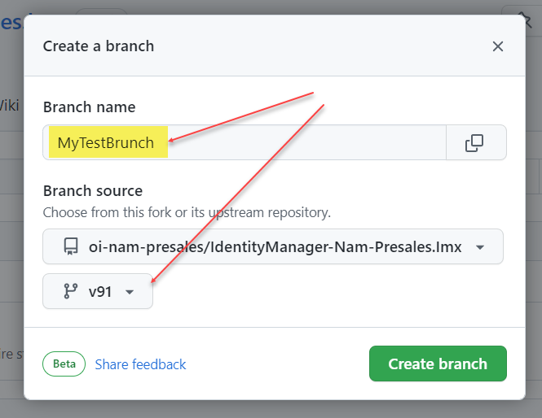

1. Open VS Code

Then: File -> Open Folder -> browse to C:\Projects\WebPortalV9\IdentityManager-Nam-Presales.Imx\imxweb

1. Set current branch in VS Code: See image below

In Source Control tab (1) -> Under Remotes (2) open UNITE folder -> Select Start -> click on Switch to another branch (3) (Rounded arrow) -> your branch becomes marked as current under Branches – UNITE/Start (4).

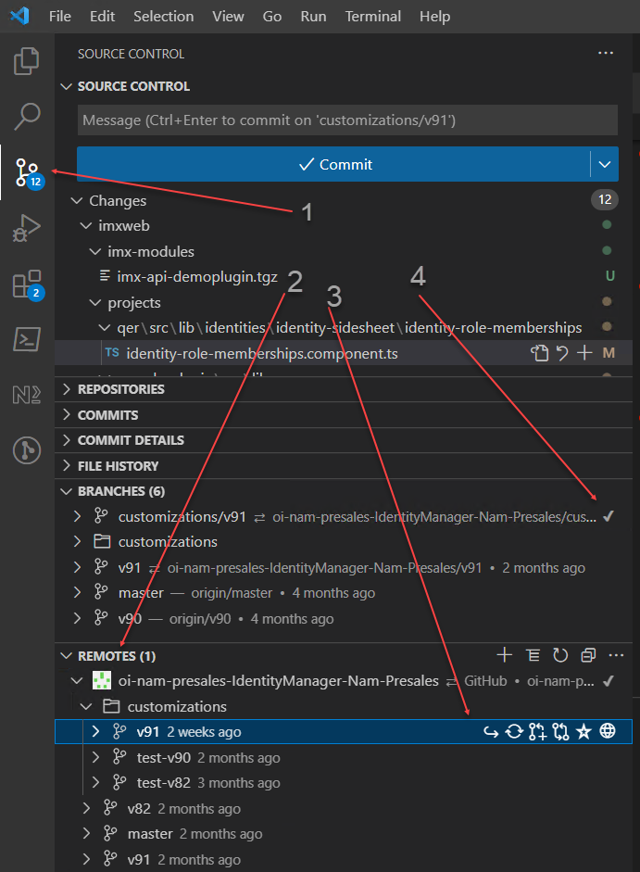

You might need to press enter if pop-up windows appear:  
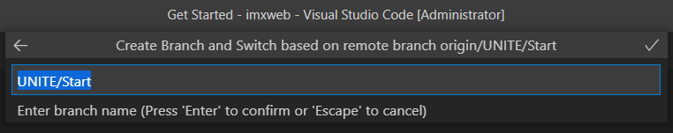

1. Install Angular if not installed yet.

To check if Angular is installed and version - run command **ng -–version** in command prompt.

1. Click Terminal menu to add a terminal
2. New terminal
3. Run command:

npm install --save-dev @angular/cli@latest (Locally) (use: @13.3 for specific version)

npm install -g @angular/cli

OR

npm install -g @angular/cli@13.3 (for specific version)

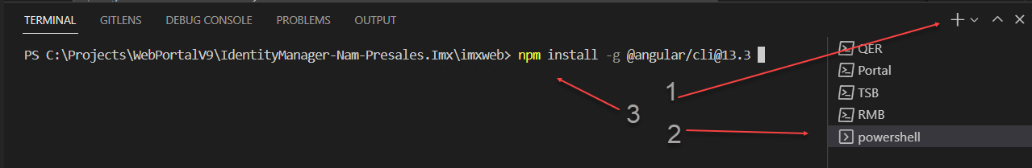

You can see which version of Angular to install in the VS Code Explorer (1) file package.json:

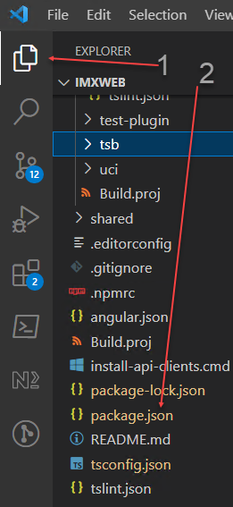 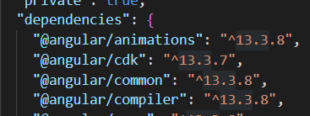

1. Install node modules the portal is dependent on:  
   In VS Code terminal run: npm install. New folder node_modules appear under folder IMXWEB
2. Build Libraries:  
   In VS Code terminal run: npm run build qbm (then - qer, tsb, etc.).  
   More (as needed) - att, rms, aad, aob, uci, cpl, hds, dpr, o3t, olg, pol, etc.  
   See table "Angular libraries" at [GitHub - OneIdentity/IdentityManager.Imx](https://github.com/OneIdentity/IdentityManager.Imx#workspace-overview)   
   They appear in IMXWEB\dist\ etc.
3. Build Applications:   
   In VS Code terminal run: npm run build qbm-app-landingpage (then qer-app-portal, etc...)  
   See table "Angular apps" on page [GitHub - OneIdentity/IdentityManager.Imx](https://github.com/OneIdentity/IdentityManager.Imx#workspace-overview)

Now Web Portal is built and is ready to run!

1. Run Web Portal

To run Web Portal locally we need to run imxclient.exe first. It runs ApiServer locally.

1. In Command Prompt run command:

"C:\Program Files\One Identity\One Identity Manager\imxclient.exe" run-apiserver -B

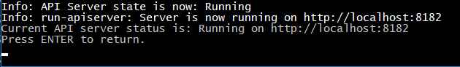

1. When dialog pops up – log in as a system user.

ATTENTION:

1. When login prompt pops up - make sure database connection starts with computer name, not "localhost"
2. If user is unable to log in and if API Server error says:

**Error: SQL injection detected in WHERE clause**

Then Go to Designer -> Base Data-> Configuration Parameters->

QBM -> SQL Check -> RiskEvaluation - Set to **LOW**.

*(****Use this for development only****)*

1. In VS Code terminal run command: npm run start qer-app-portal

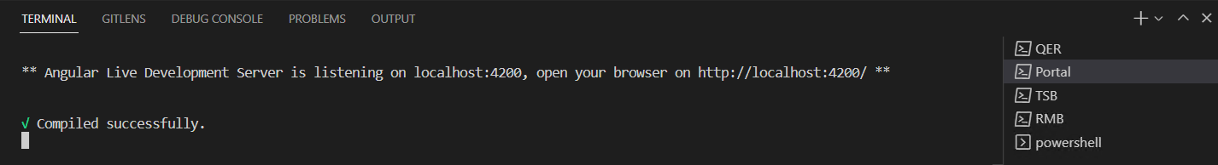

1. Navigate to <http://localhost:4200>

Now you are running Web Portal locally, can view errors and messages in the command window:  
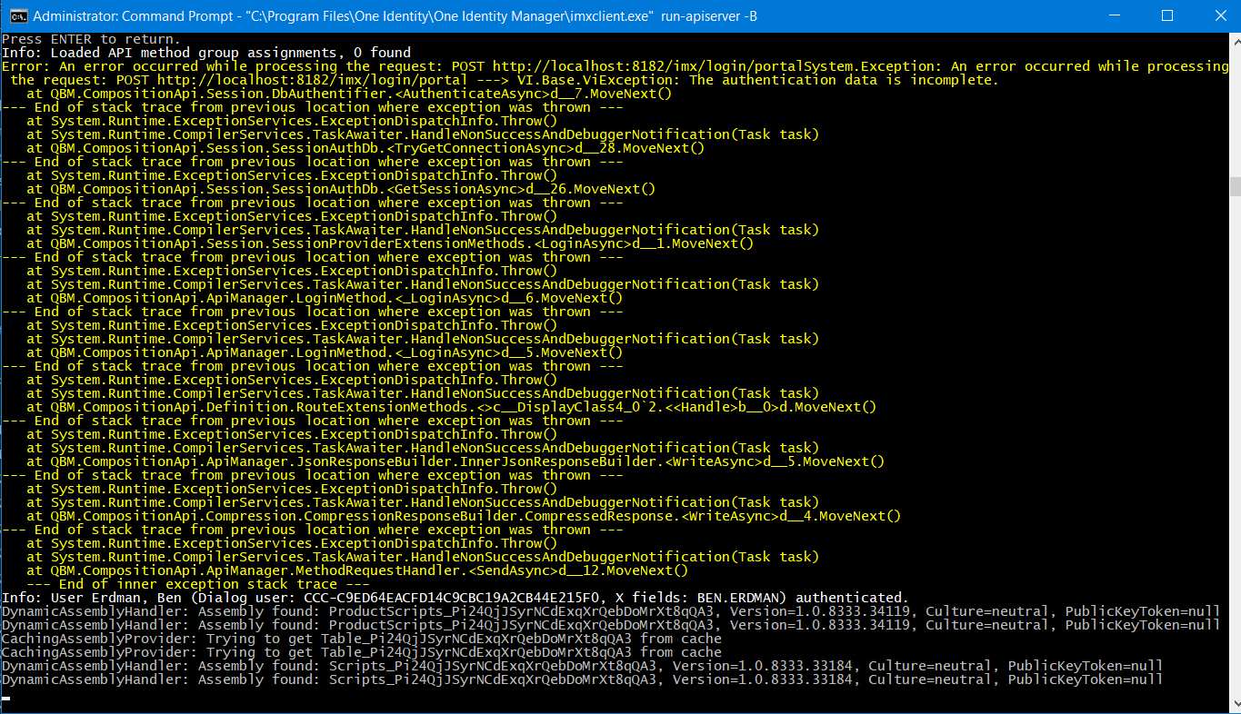

Working with Web Portal

See [Identity Manager 9.1 - HTML5 Development Guide](https://support.oneidentity.com/de-de/technical-documents/identity-manager/9.1/html5-development-guide)

Debug

Find component to debug

1. Run installed Web Portal - https://<server>/ApiServer/html/qer-app-portal/#/
2. Find a page to be debugged (Membership -> User Accounts)

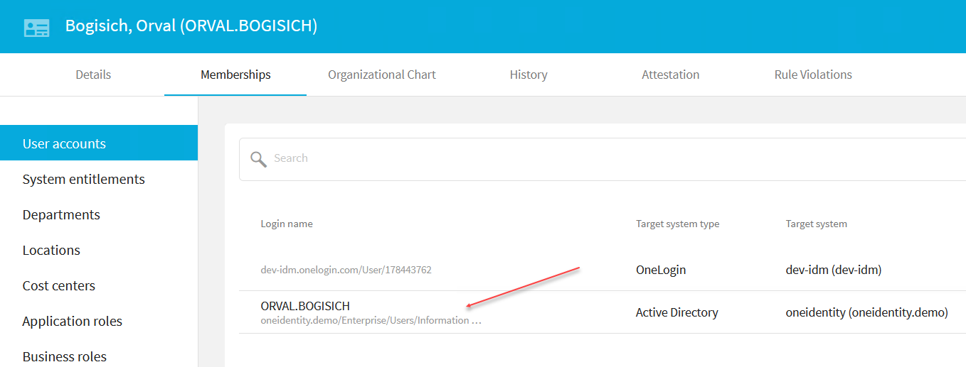

1. Right click on some item within this page and select “Inspect” from pop-up menu

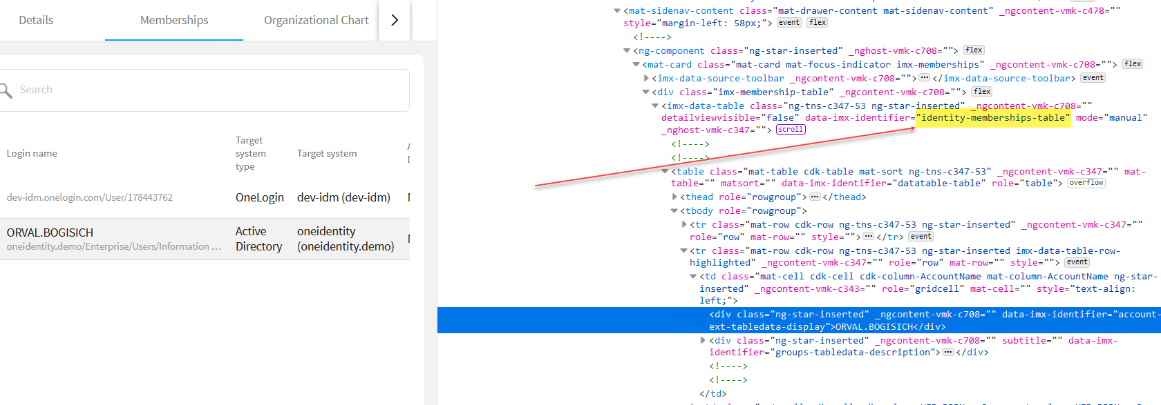

1. Find identifiable object. Like “identity-membership-table” above. Copy text.
2. In VS Code paste this text to the search window.

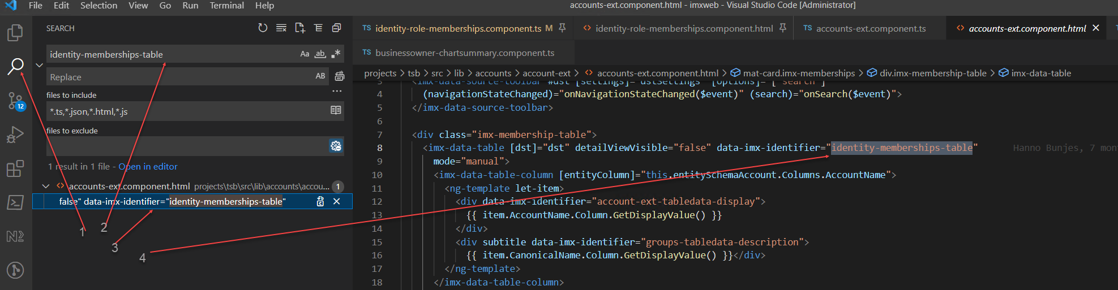

1. Search tab
2. Search Window
3. Search result. Click on result.
4. Html file where search result is located opens.
5. While the result html page is open - click on “Explorer” tab in VS Code.

There you can see the module this page belongs to and the rest of the files that belong to the module.  
In Angular the TypeScript and corresponding html file have the same name:

accounts-ext.component.html and accounts-ext.component.ts

TypeScript file contains code, logic, and data, which is used in the Html file

1. VS Code Explorer tab

2. Module where found page is located (tsb in this case)

3. Html page

4. Corresponding TypeScript file where modifications will be made.

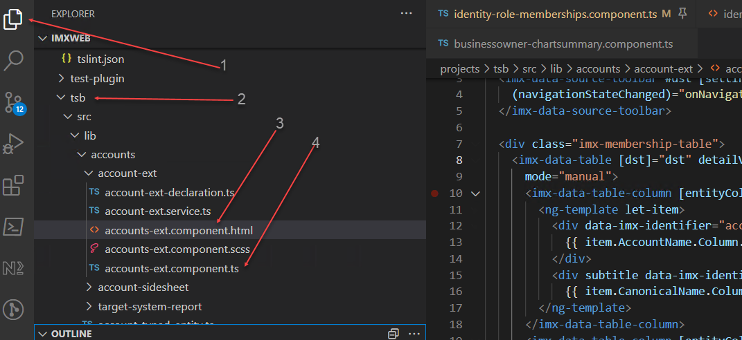

1. Open .ts file and set breakpoints where the code execution will stop.

To set breakpoint – click on the side of the window, left from the line number on the line where you want execution to stop.

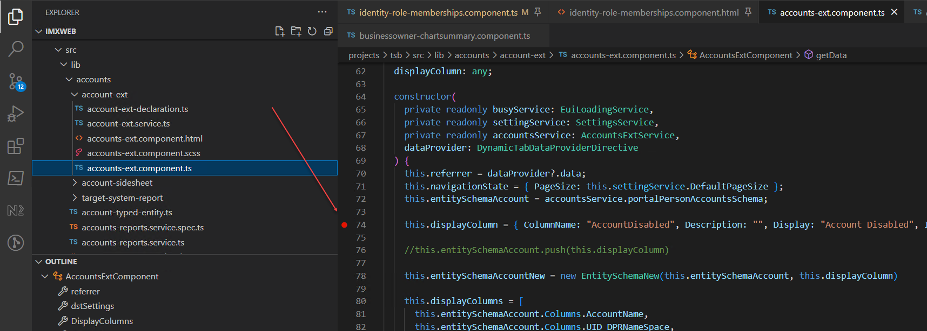

Run in debug mode

To debug a module, it needs to be built in Development configuration (qer, qbm) or Dynamic configuration (plugin libraries).

If dynamic library is not compiled in dynamic configuration – it will not appear in the Web Portal during debugging.

1. Run libraries in debug mode – [see a list of libraries](https://github.com/OneIdentity/IdentityManager.Imx#angular-libraries) .

In VS Code terminal run command following commands (run one command per terminal, multiple terminals can be opened).

When libraries are built in Dynamic configuration – the output is placed into \html\ folder.

* For static libraries: npm run build:watch qbm, npm run build:watch qer
* For plugin (dynamic) libraries: npm run build:watch:dynamic tsb ,att, sample-plugin
* Run portal: npm run start qer-app-portal

So, in our case:

* Open another terminal, rename it to “tsb”
* run: npm run build:watch:dynamic tsb
* In original open terminal run: npm run start qer-app-portal

1. Start debugging
   1. Run local ApiServer: "C:\Program Files\One Identity\One Identity Manager\imxclient.exe" run-apiserver -B
   2. Run Web Portal in debug mode:
      1. In VS Code click on “Run and Debug” tab
      2. Select a configuration from drop-down list: QER App Portal (Chrome)

See all debug configurations in launch.json file

Click on green triangle to start debugging.

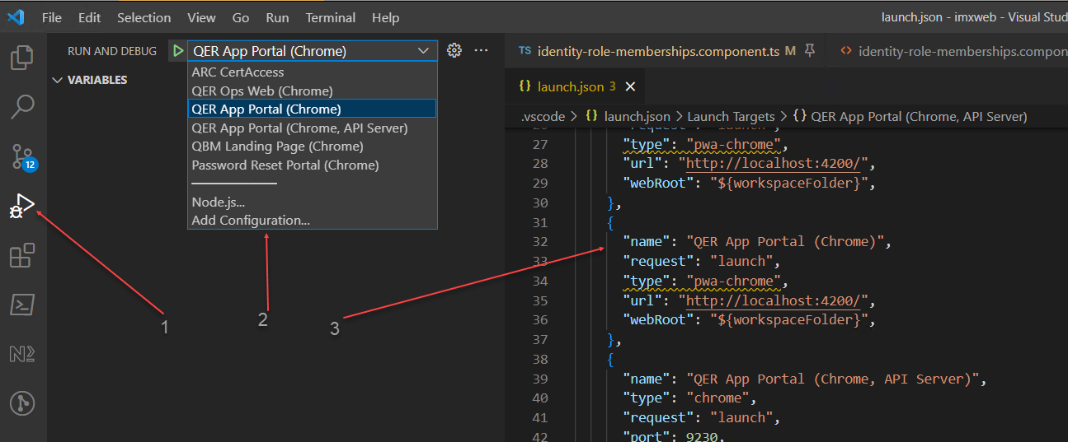

Browser will open and Web Portal will load. Code execution should stop now at the breakpoint.

If **Chrome** browser hangs while loading first page after opening – do following:

- Disable built into VS Code JavaScript Debugger:

1,2 - In Templates search for **@builtin @id:ms-vscode.js-debug**

3 – Click on debugger

4 - Click Disable button

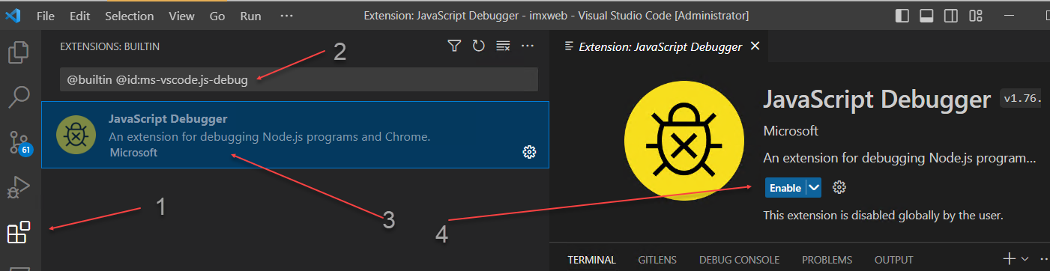

- Install JavaScript Debugger Nightly

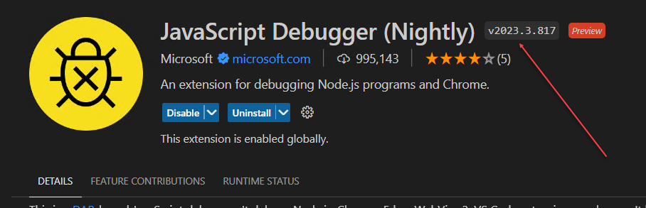

When execution is stopped at the breakpoint, we can view data and see values of variables.

For example: below we can see entity schema returned from ApiServer in call: this.entitySchema = this.roleMembershipsService.getSchema(this.referrer.tablename);

We can view all columns returned and decide whether we need to modify a call to ApiServer to return an extra column.

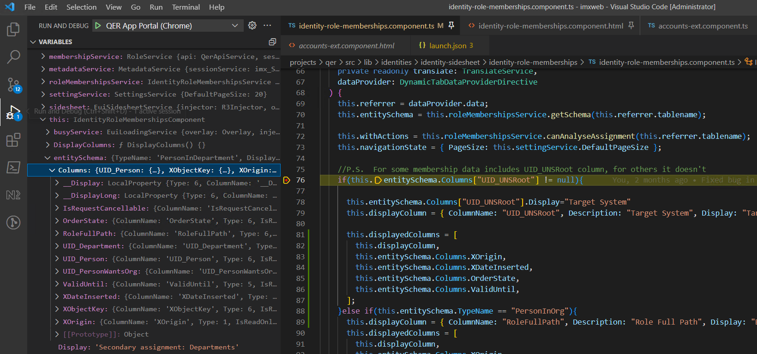

Modify

When code in the module is modified – the module needs to be recompiled.

If module is compiled in dynamic mode:

npm run build:watch qer or npm run build:watch:dynamic tsb - then it is being watched:

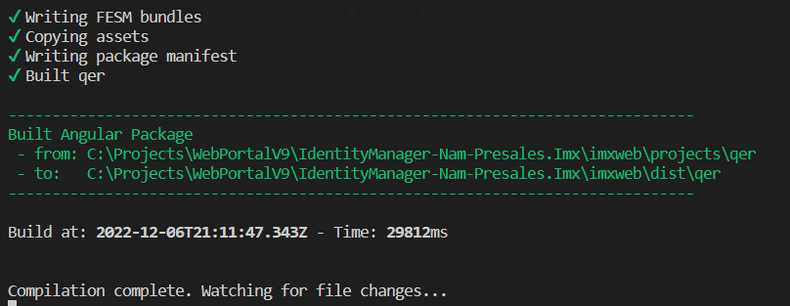

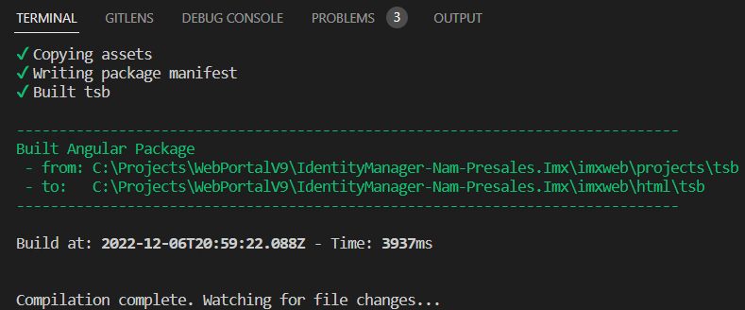

This means that as soon as changes in any file of the module are made and file is saved – compilation is started, and new version of the compiled component is placed into \imxweb\html.

Add line **<b>Testing modification of the dynamic component</b>**

right above <imx-data-source-toolbar #dst in the file accounts-ext.component.html

See how the code gets recompiled as soon as it is saved.

View this new line in the portal:

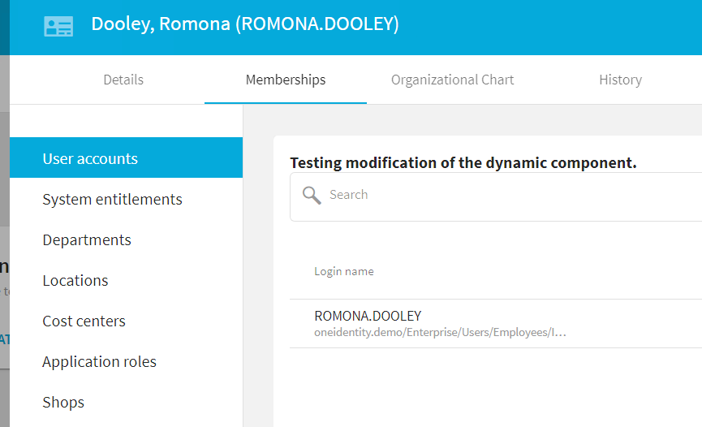

Deploy to ApiServer

To deploy compiled component to installed ApiServer in C:\inetpub\wwwroot\ApiServer components need to be compiled in production configuration.

**Static libraries (QBM and QER) don’t need to be deployed**. Applications and dynamic libraries will embed static libraries while building. So, if QBM or QER library is modifies we need to re-build portal and libraries that use it (unless change is minimal).

[See list of libraries and their dependencies](https://github.com/OneIdentity/IdentityManager.Imx#angular-libraries)

Commands are:

* QBM, QER - just build: npm run build qbm
* Dynamic Or Static libraries: npm run build:lib qbm, tsb etc...
* Applications: npm run build:app qer-app-portal

When above commands are executed, a compiled module appears in the \imxweb\dist

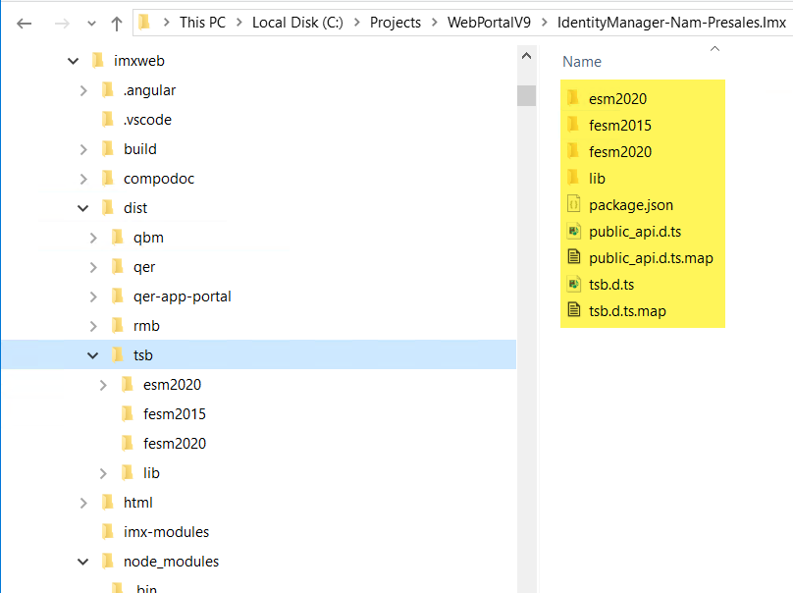

Using 7-Zip, add everything inside the module folder to the zip file and give it a name: Html_<module name>.zip (Html_tsb.zip)

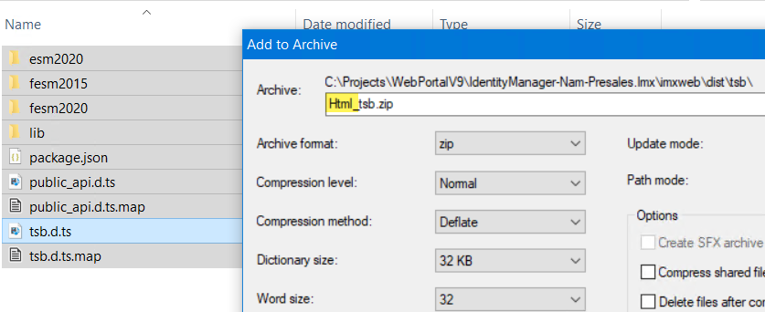

When zipping qer-app-portal – delete html folder from resulting folder before zipping.

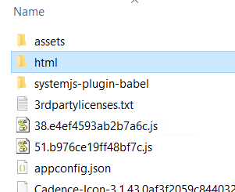

Move zipped file to the folder C:\inetpub\wwwroot\ApiServer\bin\imxweb\custom

If \imxweb\custom does not exist – create it.

If changed page does not appear in the portal – try to clear browser cache and cookies.

Deploy with Software Loader

1. Open Software Loader, Select Import into database, Log in.
2. Set Root directory to a folder where ApiServer is installed - C:\inetpub\wwwroot\ApiServer
3. Open \bin\imxweb folder, select a file to be uploaded. Click Next.
4. Assign machine role - /Server/Web/Business API Server
5. Set label, continue to the end.

Assigning machine role “Business API Server” assures that on target Job Server this file will be copied to the <ApiServer installation folder>\bin\imxweb folder.  
  
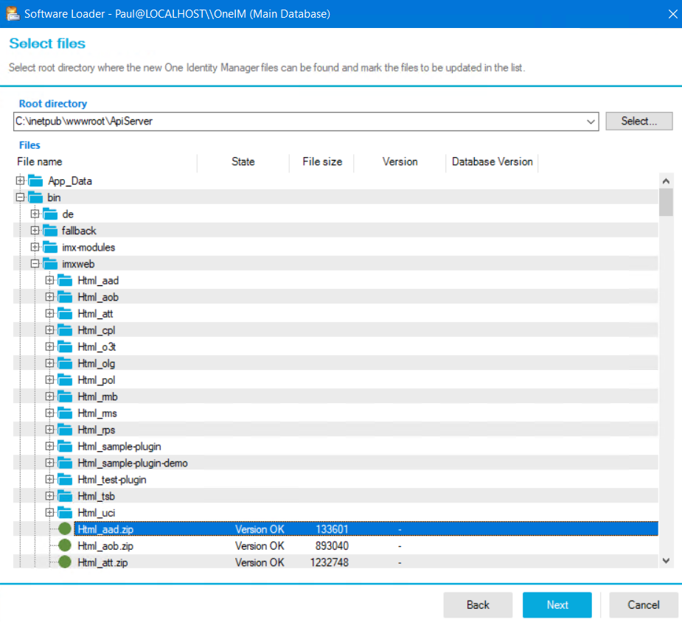

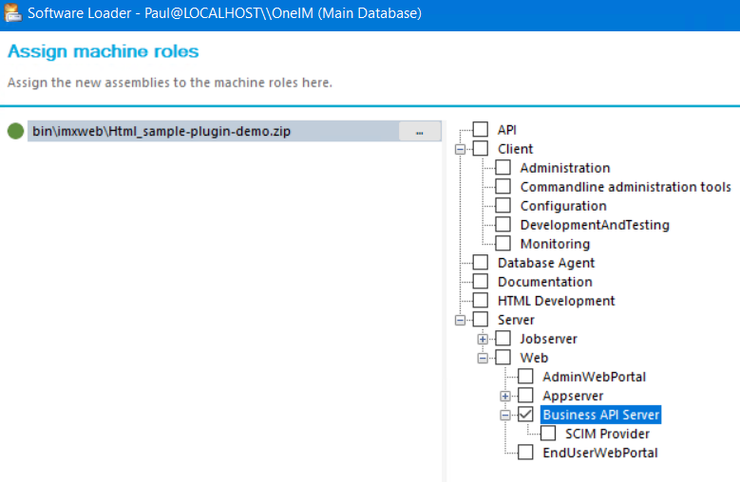

Working with Api Server

Executing REST Api methods and viewing data

All data used in Web Portal comes from IM database via ApiServer.

ApiServer exposes REST Api for clients to use for reading/writing data.

REST Api contains hundreds of methods. To document various methods and to test them ApiServer uses swagger-ui

Swagger-ui gives each methos a visual representation and capability to execute it with parameters and view the result.

See [Identity Manager 9.1 - API Development Guide](https://support.oneidentity.com/de-de/technical-documents/identity-manager/9.1/api-development-guide)

Open swagger

URL: https://dc01.oneidentity.demo/apiserver/html/qbm-app-landingpage/#/swagger-ui

URL for locally run ApiServer: <http://localhost:8182/html/qbm-app-landingpage/#/swagger-ui>

Log In

There are several login methods for every “project”.

Projects:

* Oppsupport
* Passwordreset
* Portal
* Register

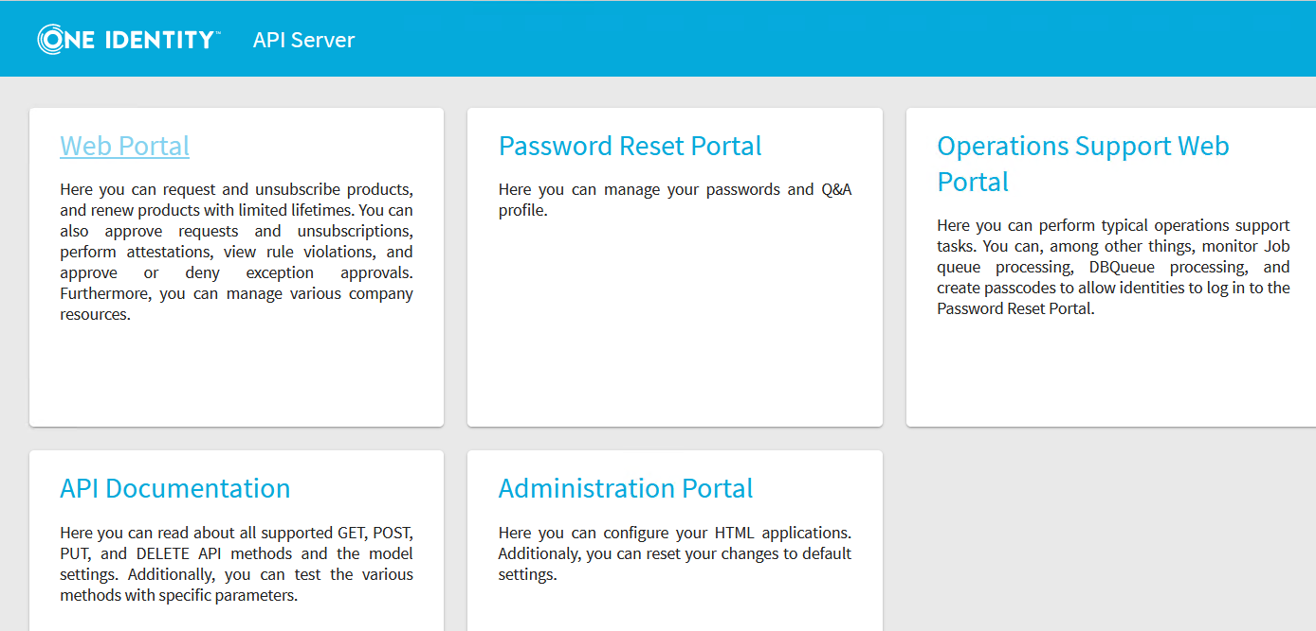

For our purpose we’ll use “portal” project, so we need to log in to portal. And we will use RoleBasedPerson Authentication Module.

* Click on POST /imx/login/{appId}
* Click on “Try It Out” button
* Select “portal” under “Name of the application”
* Select “true” under “Disable XSRF protection for the session.

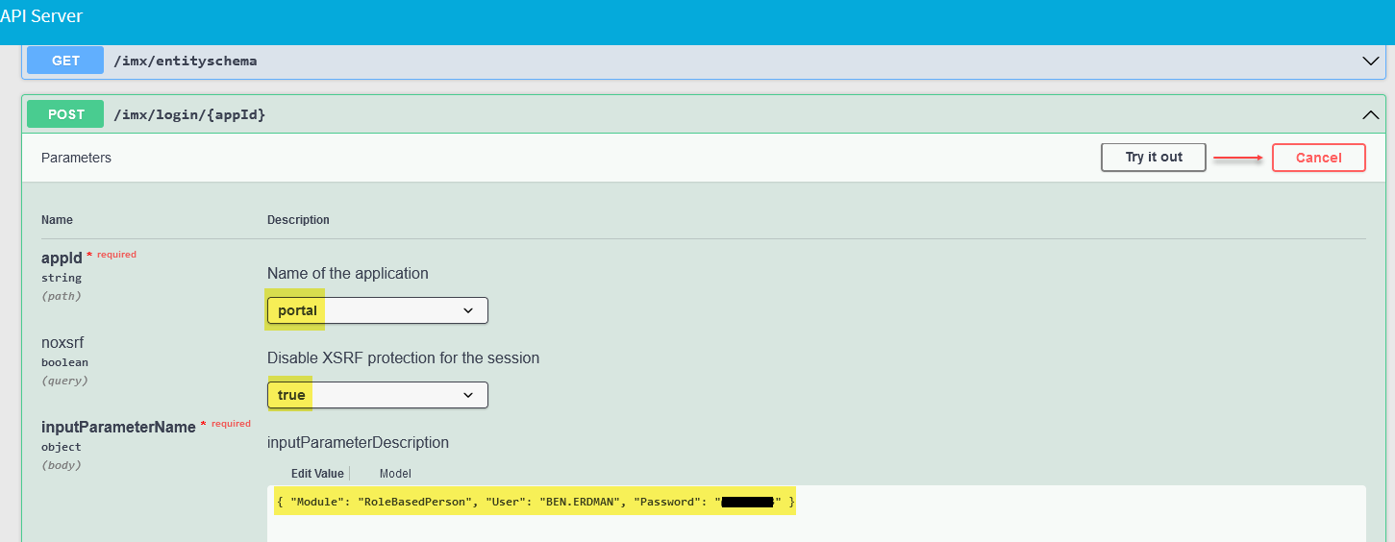

* Type {"Module":"RoleBasedPerson","User":"username","Password":"****"} into “Edit Value” window
* Click on “Execute” below.

View Responses:

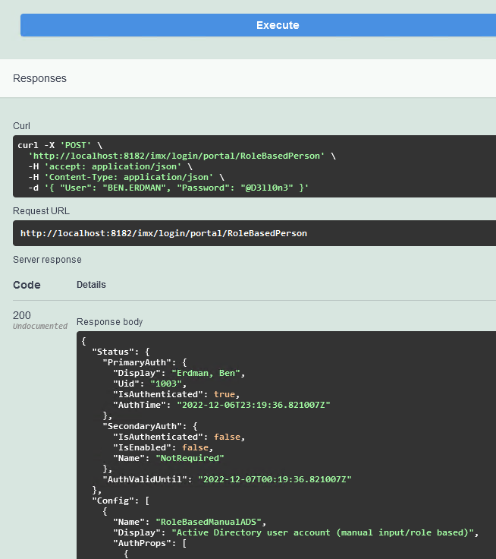

Execute a method

* Click on GET /portal/person/all
* Populate Filter with value: [{ColumnName: 'LastName',CompareOp:'Like', Value1: 'E%'}]
* Populate “withProperties” with: LastName,FirstName,CentralAccount
* These are additional columns this request will return
* Click on “Execute”

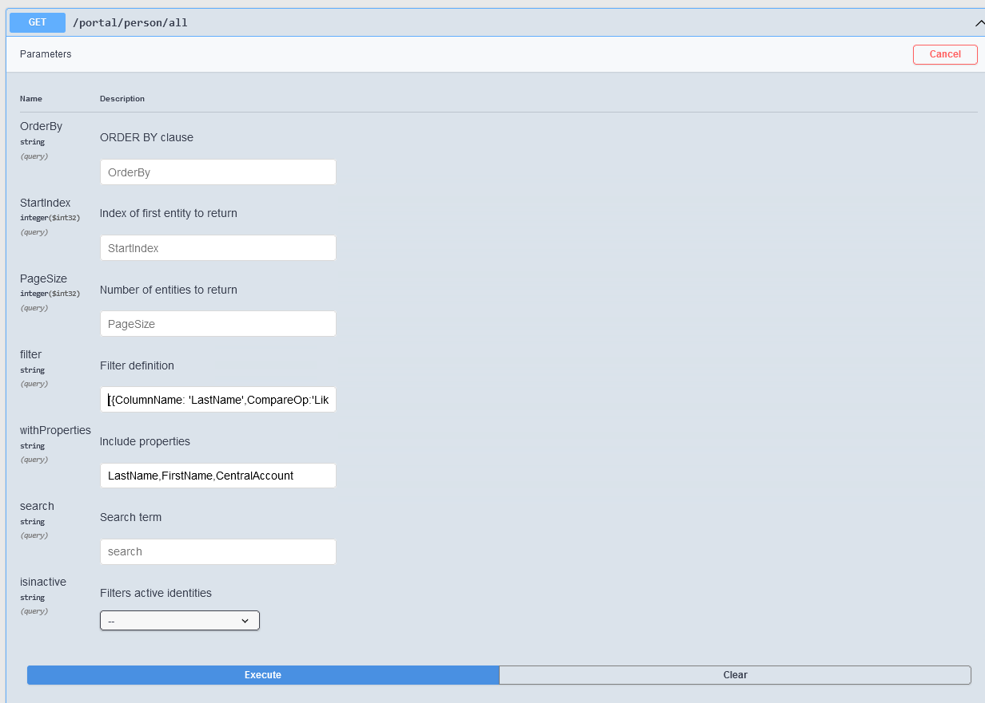

View results

Curl:

curl -X 'GET' \

'http://localhost:8182/portal/person/all?filter=%5B%7BColumnName%3A%20'\''LastName'\''%2CCompareOp%3A'\''Like'\''%2C%20Value1%3A%20'\''E%25'\''%7D%5D&withProperties=LastName%2CFirstName%2CCentralAccount' \

-H 'accept: application/json'

Request URL:

http://localhost:8182/portal/person/all?filter=%5B%7BColumnName%3A%20'LastName'%2CCompareOp%3A'Like'%2C%20Value1%3A%20'E%25'%7D%5D&withProperties=LastName%2CFirstName%2CCentralAccount

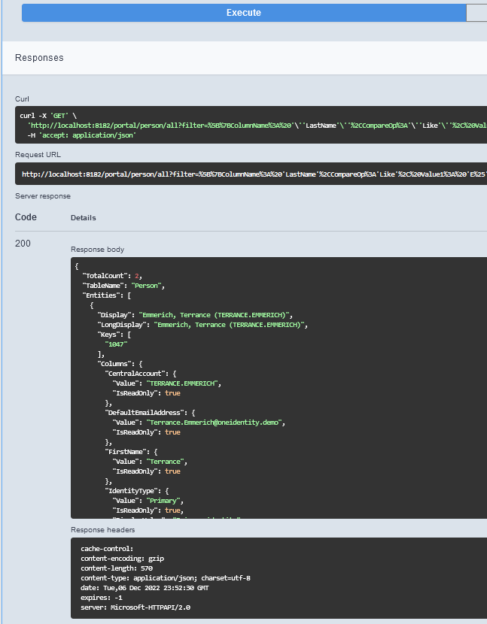

Using Postman to execute Api Server methods

Postman can be used for testing custom ApiServer plugins or regular API endpoints.

1. Open Postman
2. Import file "\UNITE\ApiServer\Identity Manager API Samples.postman_collection.json"
3. Edit collection Identity Manager API Samples set variable “url” to <https://dc01.oneidentity.demo>/ApiServer. Don’t forget to click on “Save”.

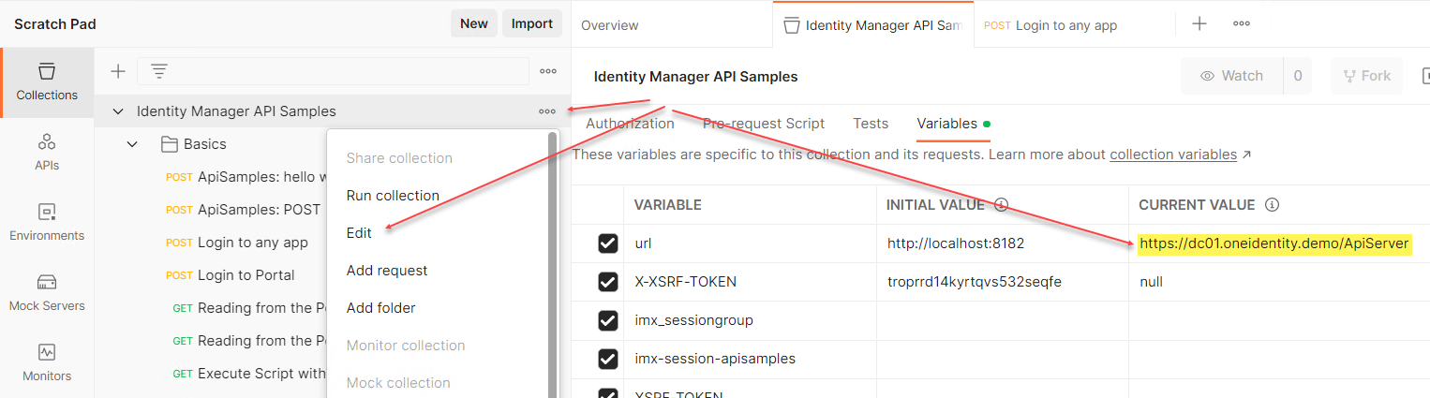

1. Click on “Login to any app”.

To disable XSRF token - pass the noxsrf=1 URL parameter when making the login request, which will disable XSRF protection for the session:

{{url}}/imx/login/portal?noxsrf=1

and Body to

{ "Module": "RoleBasedPerson", "User": "username", "Password": "****" }

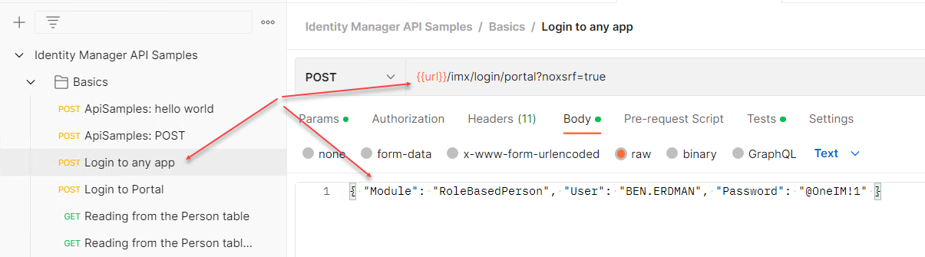

1. Click on Send, View result.

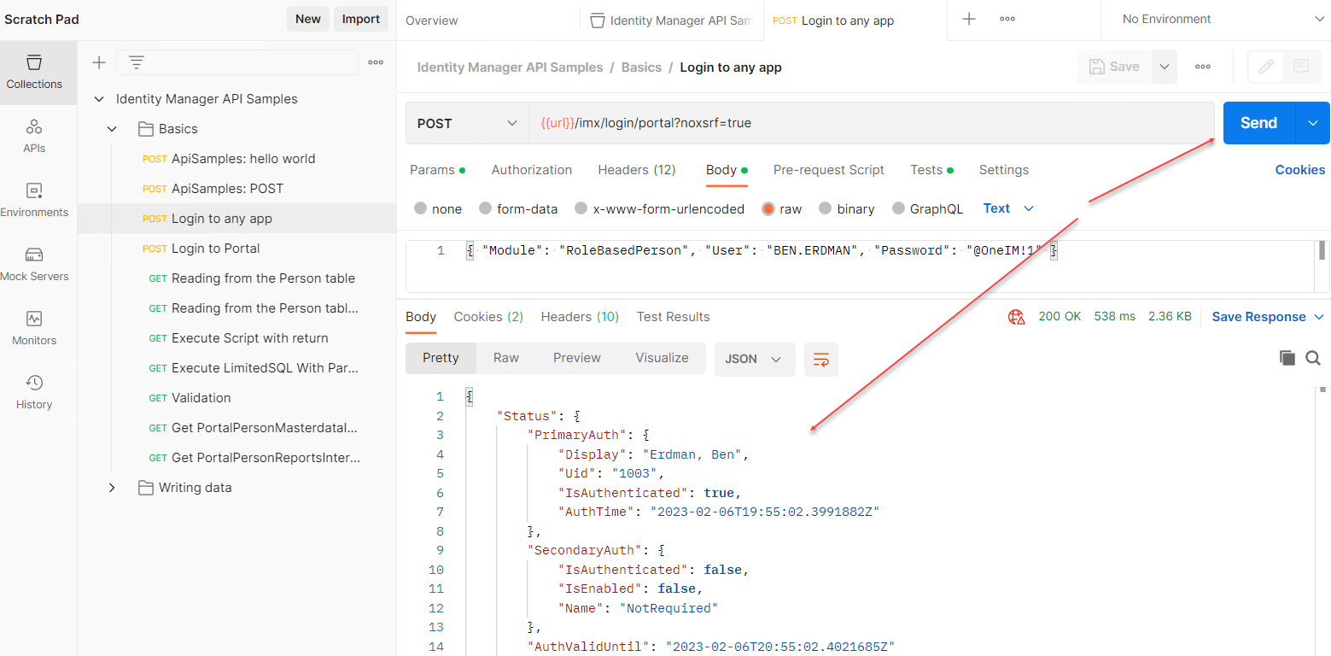

1. Open Reading from the Person Table with a filter
2. Change URL to {{url}}/portal/person/all?filter=[{ColumnName: 'LastName', CompareOp: 'like', Value1: 'E%'}]
3. Click on Send, view result:

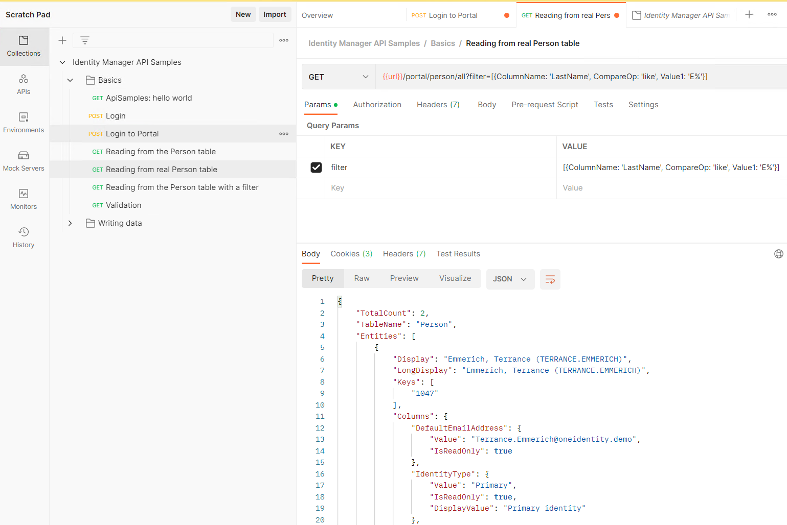

Customizations

Simple modifications

Customizations not requiring modifications in either Angular or in ApiServer modules.

1. Change Top Logo color

Stylesheet to make top logo color red:

<style>

.eui-masthead, .eui-masthead .mat-toolbar.mat-primary {

background-color: Red !important;

}

</style>

Steps to modify:

1. Extract Html_qer-app-portal.zip (From C:\Program Files\One Identity\One Identity Manager\imxweb directory) to a temporary folder
2. Edit the index.html file inside that folder
3. Add the style above inside the HTML <head> tag
4. ZIP the modified set of files as Html_qer-app-portal.zip (Note: Do not include the Html_qer-app-portal folder in the zip, only the files in that folder. If you do, you may get a HTTP 404 error when you access the page)
5. Move the ZIP file to C:\inetpub\wwwroot\ApiServer\bin\imxweb\custom\Html_qer-app-portal.zip on the API Server installation (or use software loader)

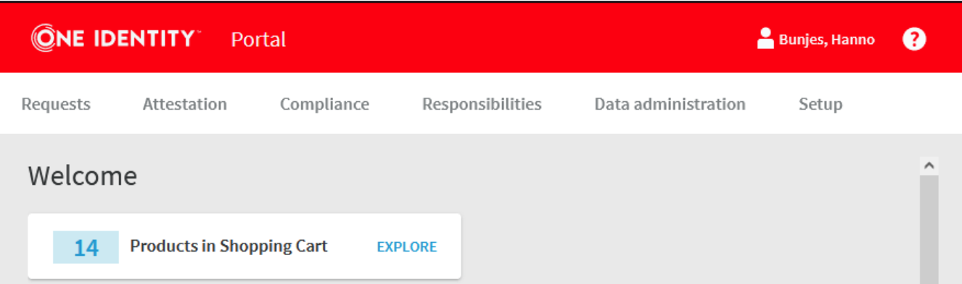

1. Change Top Logo and main background color

Repeat same steps as above

body {

background-color: #CBC3E3 !important;

}

/*Color of the top bar*/

.eui-masthead,

.eui-masthead .mat-toolbar.mat-primary {

background-color: #5d3fd3 !important;

}

</style>

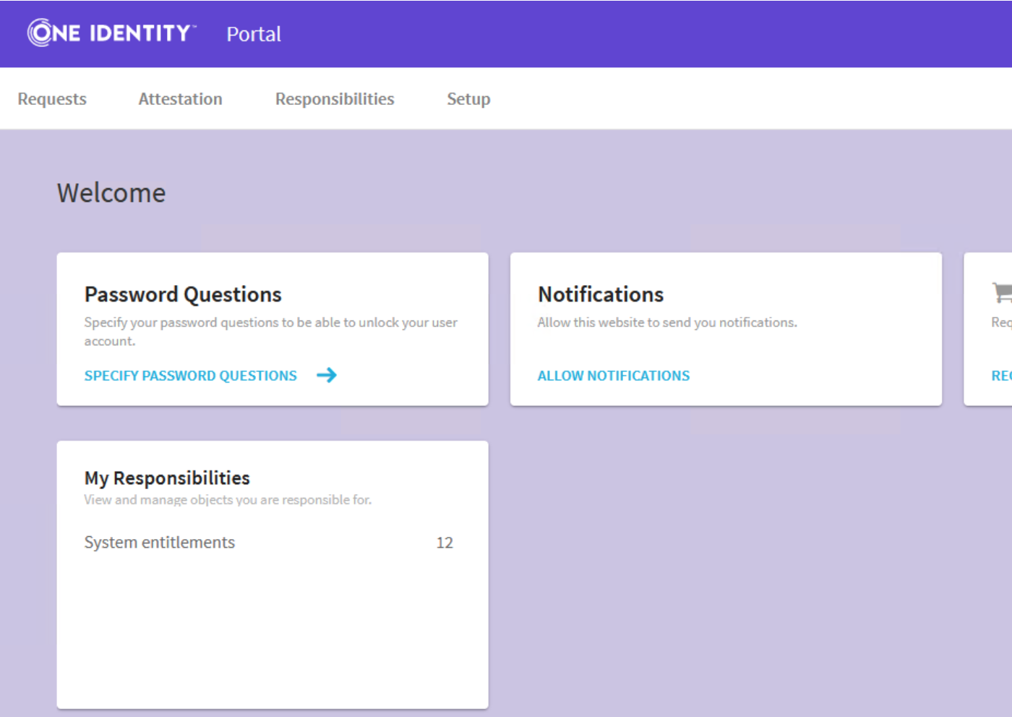

1. Change background image

Repeat same steps as above

<style>

body{

background-image: url(../../OneIdentityQuest.png);

background-repeat: no-repeat;

background-size: cover;

}

/*Color of the top bar*/

.eui-masthead,

.eui-masthead .mat-toolbar.mat-primary {

background-color: #5d3fd3 !important;

}

</style>

The image can be places in the top folder:

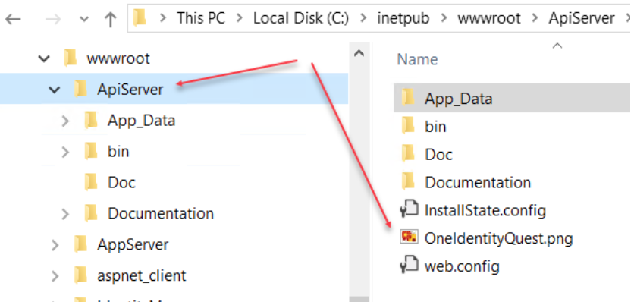

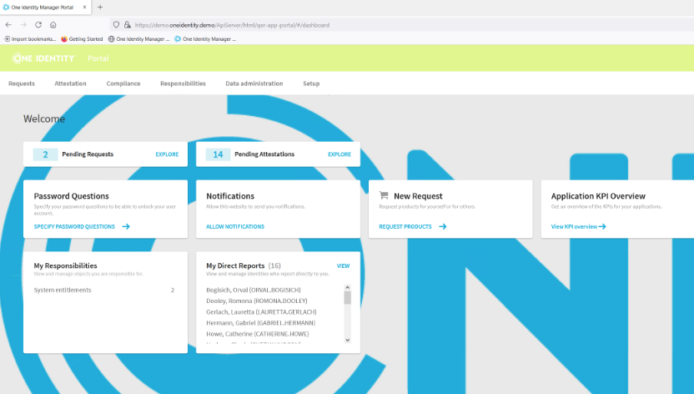

1. Change Logo image

Add logo file to the API Server installation directory.

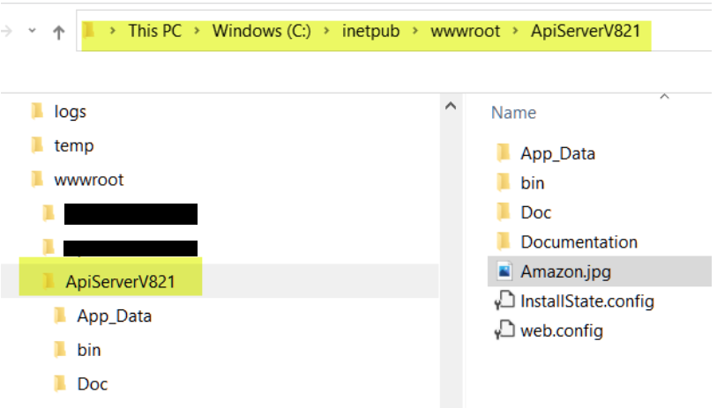

Go to Administration Portal on API Server

Select Configuration tab.

Select imx under Show configuration for the following API project dropdown box.

Under API Server configuration -> Company logo enter: /ApiServerV821/Amazon.jpg

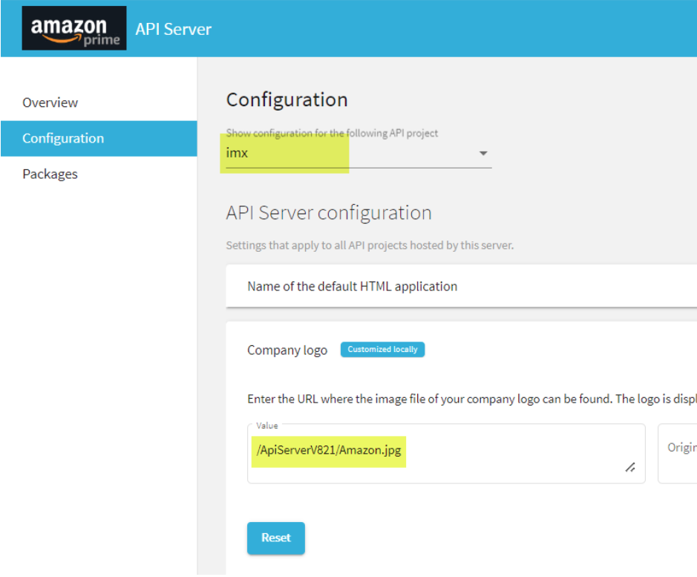

1. Show additional columns for Dynamic Roles

The below pulldown list of properties that can be used in dynamic roles is controlled via the "Show in wizard" checkbox.

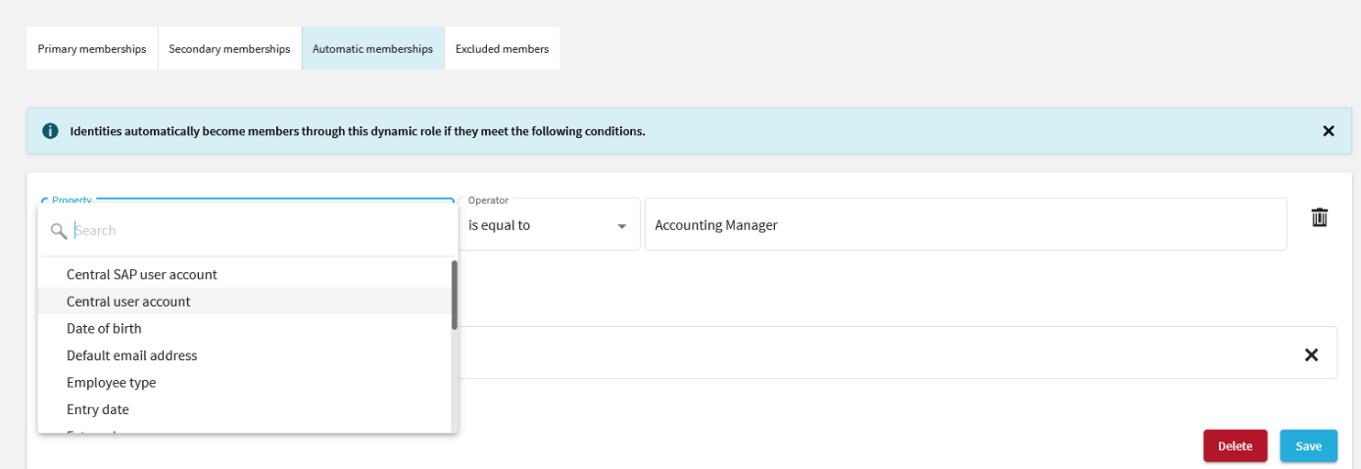

Designer view of the Show in wizard checkbox.

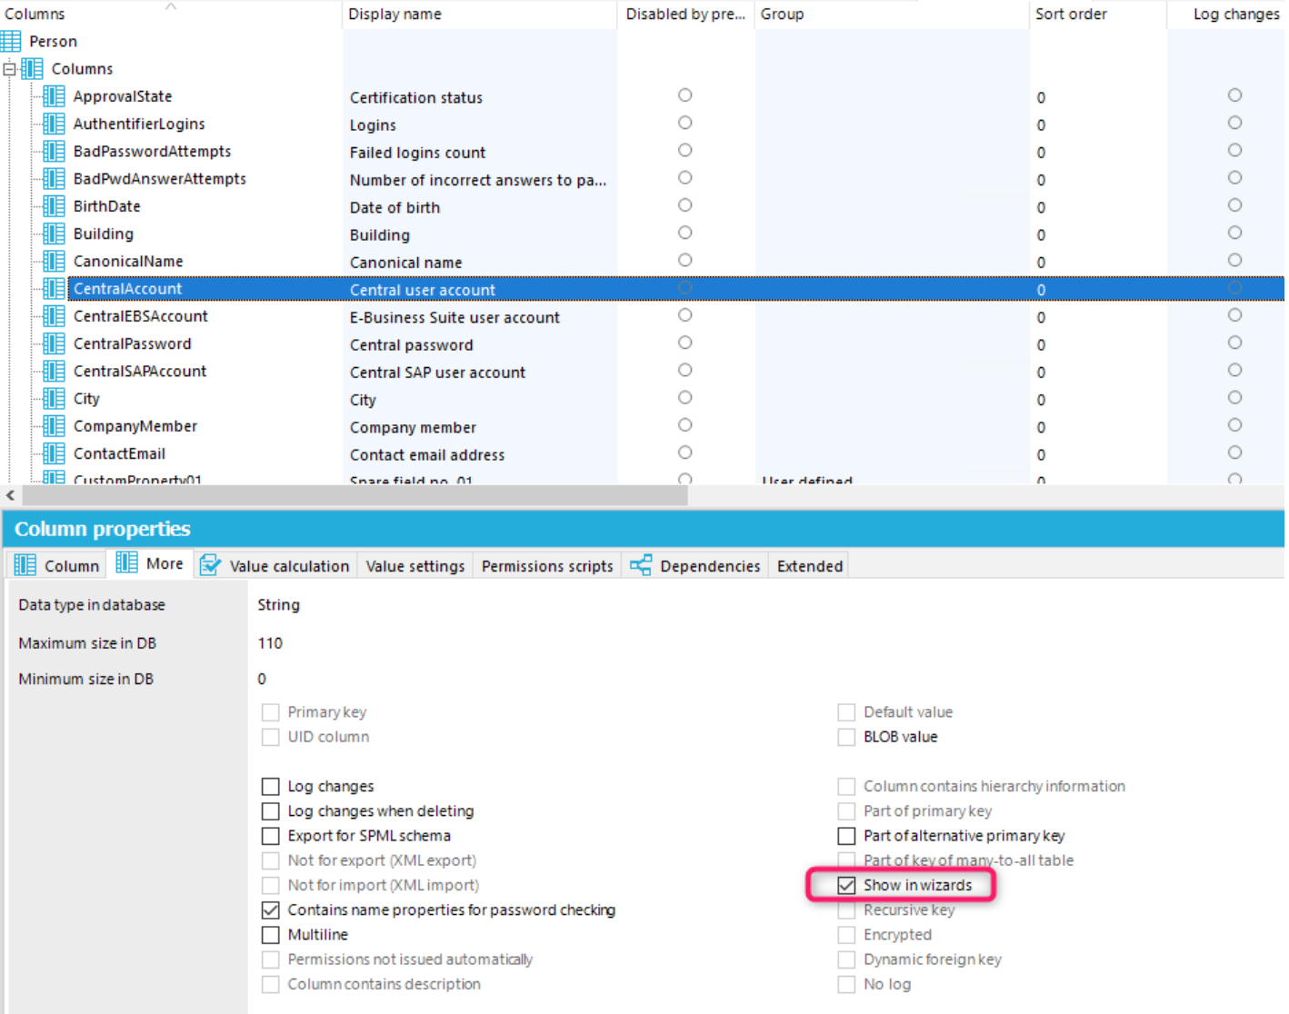  
  
After making the changes, you need to **Commit and Compile**, and then restart the API server

Advanced ApiServer Modifications

Build Custom Plugin

We will be using ApiSamples Visual Studio solution located in:

<IM-distribution>\Modules\QBM\dvd\AddOn\ApiSamples for code samples.

Source code for ApiServer is not available, so every time we need to extend functionality of the ApiServer (like reading data from some complex SQL statement or adding/modifying records in IM) we need to create a custom plugin

This plugin will be added to the qer-app-portal API project to extend portal functionality.

It will accept user’s login to the portal and all endpoints will look like:

<server>\portal\<method endpoint>.

There are two Visual Studio solutions provided in \UNITE\ApiServer folder. They contain UnitePlugin and SamplePlugin solutions. SamplePlugin solution is not necessary, but it show that methods from multiple custom plugins will be combined in the client .tgz file when it is built.

Create Plugin

* 1. Open Visual Studio 2022 (2019, 2017 is also fine)
  2. Create new project
     1. Select “C# Class Library (.NET Framework)”
     2. Select a working folder C:\Projects\ApiServer
     3. Give solution a name UnitePlugin.CompositionApi.Server.Plugin

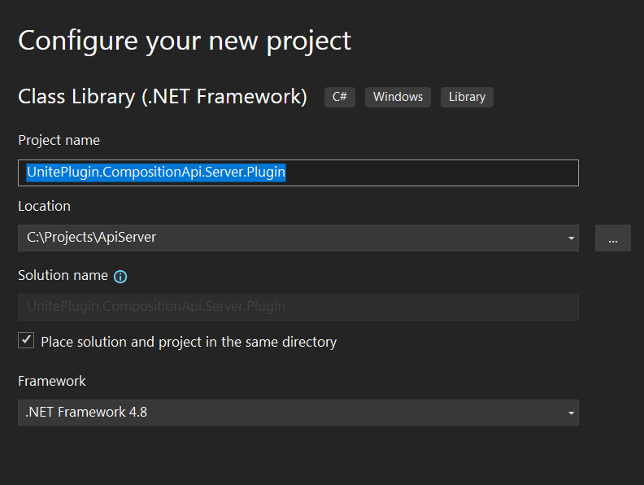

Result:

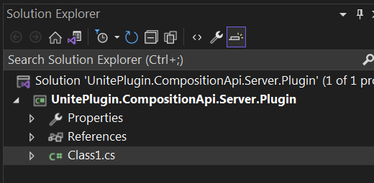

1. Configure Project
   * 1. Rename file Class1.cs to MyMethods.cs. Accept renaming class also.
     2. Make sure main class implements IApiProviderFor:

public class MyMethods : IApiProviderFor<PortalApiProject>, IApiProvider

This way the plugin will be added to the qer-app-portal API.

* + 1. Add references:

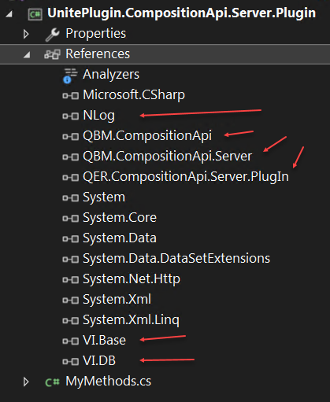

All of them are in the “One Identity” folder.

1. Copy all text from MyMethods.cs file in the distribution folder  
   UNITE\ApiServer\SamplePlugin.CompositionApi.Server.Plugin   
   into MyMethods.cs in the project. (Can just copy file)
2. In Visual Studio Solution Explorer right click on project “UnitePlugin.CompositionApi.Server.Plugin” and select Poperties

* In Application Tab configure Assembly Name and Default Namespace

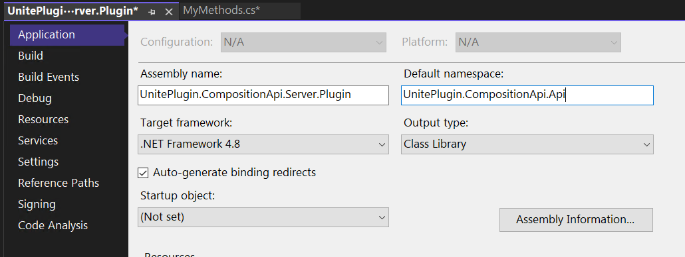

* In Debug Tab set:

Start External Program:

C:\Program Files\One Identity\One Identity Manager\ImxClient.exe

Start Options -> Command line arguments:

run-apiserver -B /plugin UnitePlugin.CompositionApi.Server.Plugin.dll /conndialog fallback

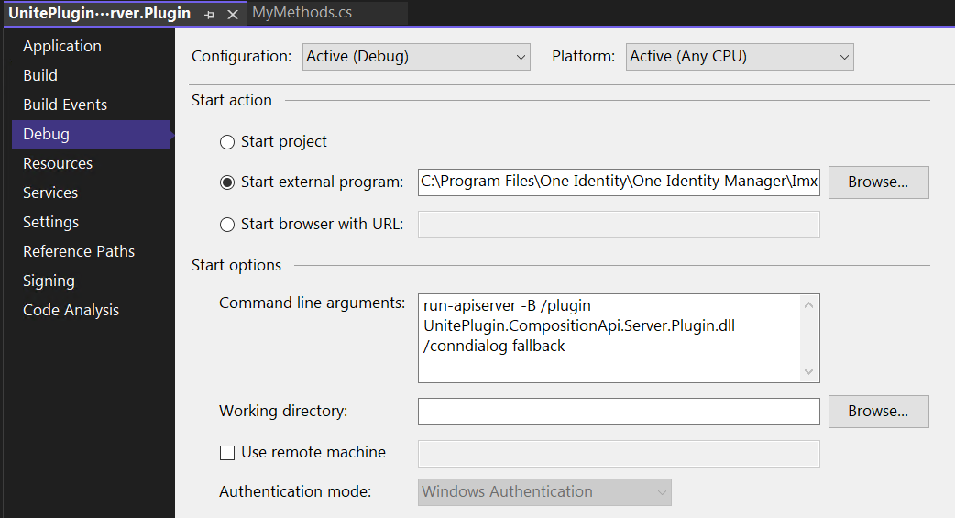

1. In Solution explorer under <project>/Properties, In AssemblyInfo.cs add the following attribute:

[assembly: QBM.CompositionApi.PlugIns.Module("CCC")]

This attribute will register plugin with CCC module.

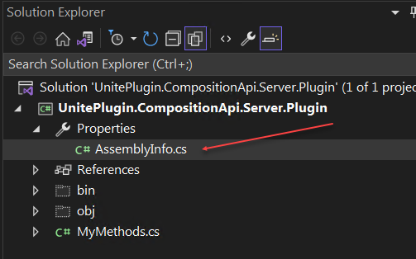

1. Methods implemented:

ATTENTION! Before executing these methods make sure a script and Predefined SQL are present in IM Designer.

Script: CCC_Call_Database_Direct

Predefined SQL: CCC_Get_Reports_With_Business_Roles

There is a transport file provided in UNITE folder.

- GET uniteplugin/getreportsrolesscript/{centralaccount}

This method calls an IM script, which retrieves a list of the user’s reports with their business roles. User is specified by “centralaccount” parameter (or UID_Person). Result is returned in standard JSON format.

'[{"ManagerCentralAccount":"BEN.ERDMAN",  
"FirstName":"Orval",  
"LastName":"Bogisich",  
"Title":"",  
"BusinessRole":"Contractor"},  
{"ManagerCentralAccount":"BEN.ERDMAN",  
"FirstName":"Orval",  
"LastName":"Bogisich",  
"Title":"",  
"BusinessRole":"Assistant to Accounting Clerk"}]’

- GET uniteplugin/getreportsrolessql/{centralaccount} (Accepts UID_Person)

This method calls IM’s Prefedined SQL to retrieve the same information as in method above. Data is returned in “standard” IM ApiServer format.

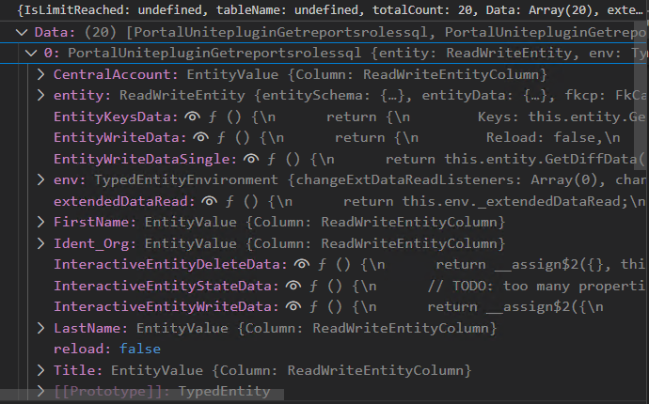

Run Plugin

1. In Visual Studio click Green Triangle (Start) or Debug Menu -> Start Debugging

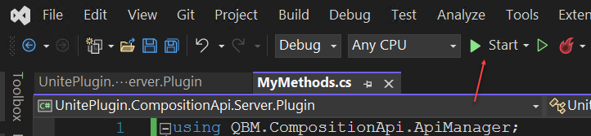

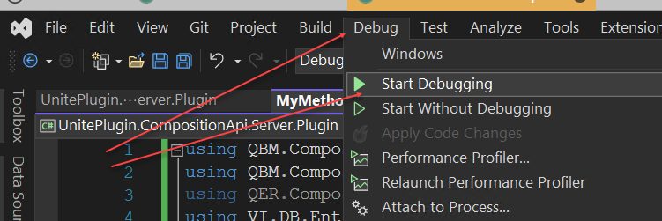

2. Log into One Identity Manager dialog as system user.

3. Watch information in command prompt. It should have no errors and should have UnitePlugin loaded:

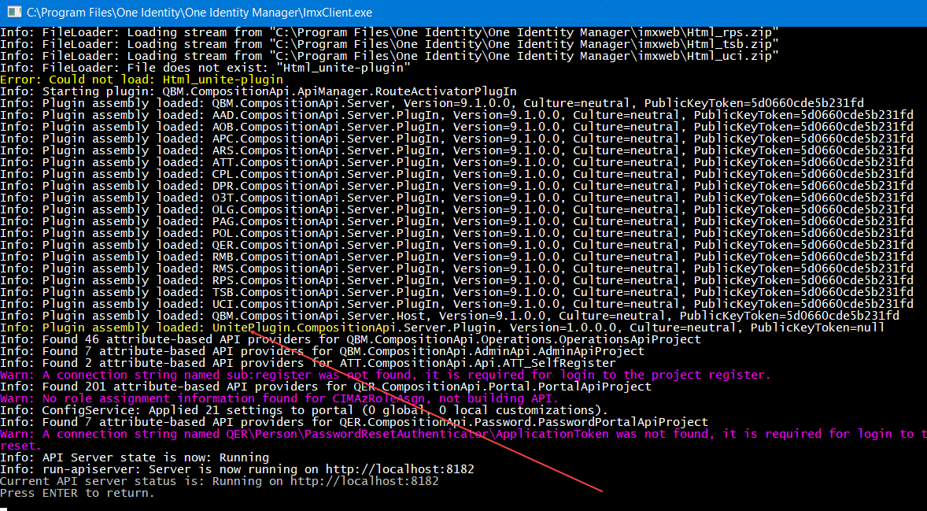

Test Plugin

1. While server is running open a browser and browse to <http://localhost:8182>

2. Click on API Documentation tile. Wait for swagger to open

3. Find custom methods:

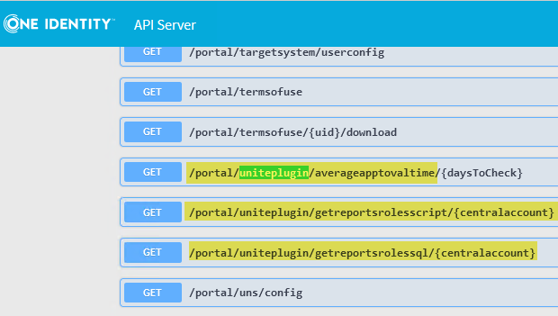

4. Login and run /portal/uniteplugin as described in Executing API Methods

Plugin is working now.

5. Plugin can be tested using Postman.

6. If VS doesn’t stop on breakpoints during debug -check if same dll already exists in C:\Program Files\One Identity\One Identity Manager directory (if it was previously deployed).

Deploy Plugin

1. Copy new UnitePlugin.CompositionApi.Server.Plugin.dll from folder C:\Projects\ApiServer\UnitePlugin.CompositionApi.Server.Plugin\bin\Debug

To Folder: C:\Program Files\One Identity\One Identity Manager

2. Run local ApiServer -In Command Prompt run:

"C:\Program Files\One Identity\One Identity Manager\imxclient.exe" run-apiserver -B

3. Watch information in command prompt. It should have no errors and should contain UnitePlugin loaded. Press “enter” to stop

4. Copy new dll to the folder C:\inetpub\wwwroot\ApiServer\bin .

5. Run iisreset in command prompt.

6. Navigate browser to <https://dc01.oneidentity.demo/ApiServer>, click on “API Documentation” tile.

7. Test your deployed API Plugin as here.

Build Client package (.tgz)

Client package is a wrapper around calls to Api Server methods.

This one will contain custom methods from new plugin dlls.

* 1. Copy new dll to the C:\Program Files\One Identity\One Identity Manager folder

**Make sure to delete it after client package is created!**   
Further debugging will not work while this dll is in that folder.

We can place dlls from both UnitePlugin and SamplePlugin solutions into this directory.

SamplePlugin.CompositionApi.Server.Plugin.dll

And

UnitePlugin.CompositionApi.Server.Plugin.dll

Then methods from both will be present in the resulting client package.

2. In Command Prompt run:

> cd C:\Program Files\One Identity\One Identity Manager

> imxclient compile-api /copyapi imx-api-uniteplugin.tgz /packagename **imx-api-uniteplugin**  
 Any name can be used for the plugin file.  
 imxclient compile-api /copyapi imx-api-<**any name**>.tgz /packagename imx-api-<**any name**>

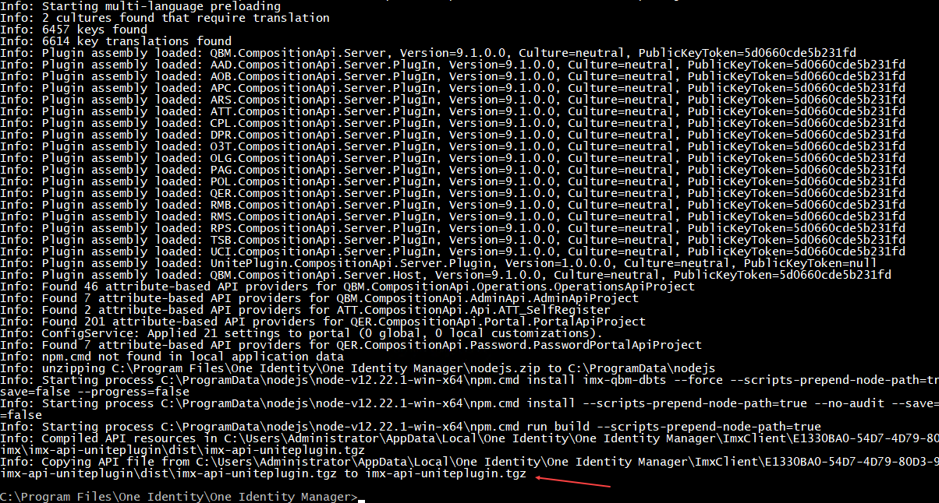

3. See new imx-api-uniteplugin.tgz in C:\Program Files\One Identity\One Identity Manager

4. Verify. Unzip file imx-api-uniteplugin.tgz , Open file TypedClient.d.ts   
 This file should contain class V2Client with methods from your dll:

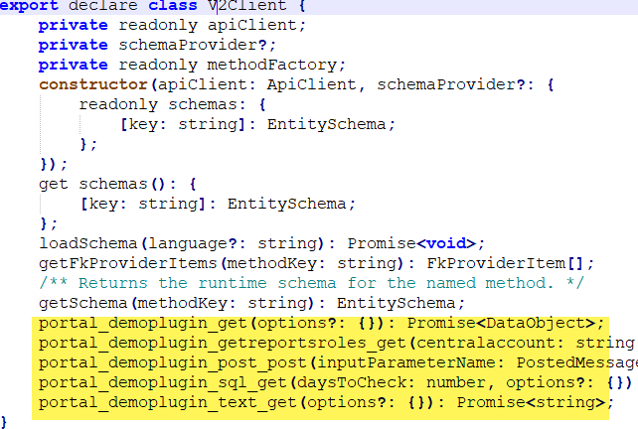

If generated file doesn’t contain methods from dll:

* Delete content of the folder:

C:\Users\Administrator\AppData\Local\One Identity\One Identity Manager\ImxClient

* Make sure following attribute is present

[assembly: QBM.CompositionApi.PlugIns.Module("CCC")]

Add client package to the Web Portal project

1. Copy file imx-api-uniteplugin.tgz to the folder

C:\Projects\WebPortalV91\IdentityManager-Nam-Presales.Imx\imxweb\imx-modules

2. In VS Code open file \imxweb\package.json

3. Add line "imx-api-uniteplugin": "file:imx-modules/imx-api-uniteplugin.tgz" to the "optionalDependencies" node.

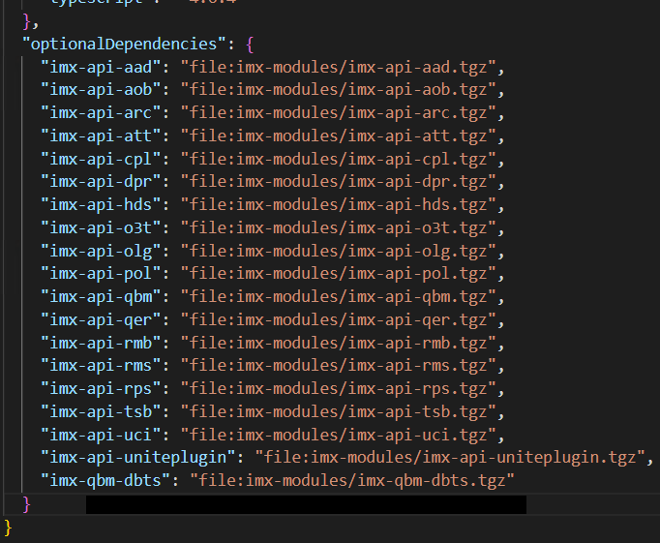

4. In VS Code terminal run command npm install imx-api-uniteplugin

This command will install package imx-api-uniteplugin in the folder \imxweb\node_modules

See client calling API Server via imx-api-uniteplugin.tgz in Advanced Web Portal Modifications

Advanced Web Portal Modifications

If VS Code gives “No quick fix available” when hovering over keyword, underlined with red – try following:

In file “tsconfig.json” add “**exclude**” node:

"angularCompilerOptions": {

...

...

},

"exclude": [

".git",

".app-cache",

".npm",

".npm-tmp",

"dist",

"dist*",

"node_modules",

"subfolder/dist",

"subfolder/node_modules",

"**/dist/*",

"**/node_modules/*",

]

}

After that restart VS Code

List of common commands used while working with Angular project.

Commands executed one per library/application.

1. To work on (edit/modify/debug) static library:

npm run build:watch qbm

npm run build:watch qer

2. To work on (edit/modify/debug) dynamic library:

npm run build:watch:dynamic tsb (att, rmb, rms)

npm run build:watch:dynamic sample-plugin

3. To run Angular application:

npm run start qer-app-portal (qer-app-pwdportal,…)

4. To Publish/Deploy to Server:

a. Static libraries don’t get deployed. Just build them:

npm run build qbm

b. Dynamic libraries

**npm run build:lib tsb** (sample-plugin, …)

1. Add column 1 – System Entitlements Membership

Find module to work on

Need to add a column which shows what system the entitlement comes from.

To get to this page select a direct report of logged in user, select “Membership” tab, and select a “System entitlements” menu.

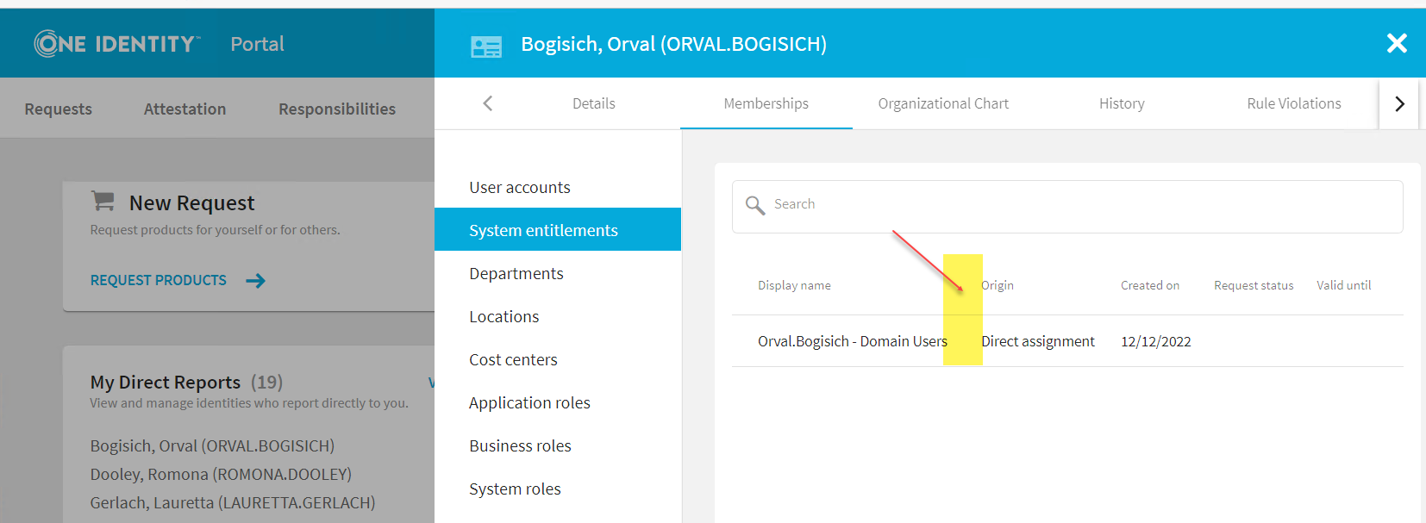

1. Right click on the name, click “Inspect” on the pop-up menu.

Find “identifiable” identifier above the inspect point.

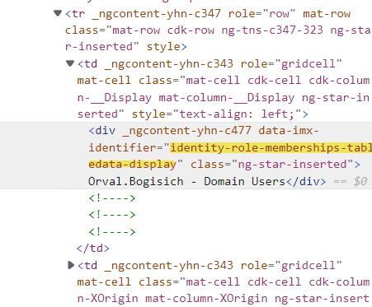

2. Paste the name from #1 into the search in VS Code.

See the results. There might be multiple results.

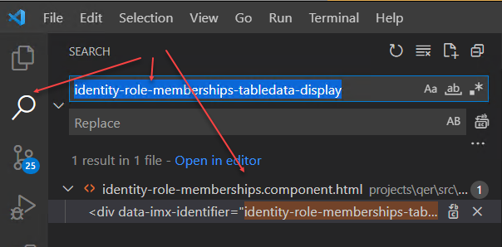

3. Double click on the result. Corresponding .html file opens up.

Click on the “Explorer” tab in VS Code.

Project tree opens with selected html file highlighted.

Select .ts file (component) with the same name as html file.

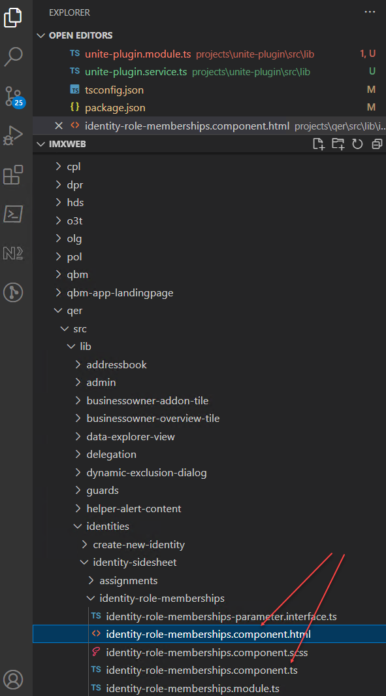

4. See what module selected html file belongs to.

In our case it is “qer”.

Start debugging

1. In VS Code open a terminal and run command: npm run build:watch qer

Wait until compiles with no errors.

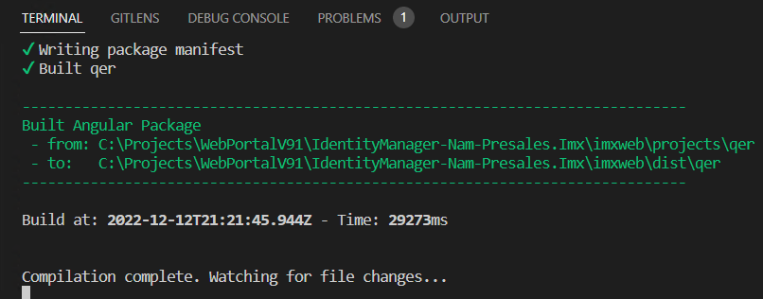

2. Open another terminal and run command: npm run build:watch:dynamic tsb

3. Open another terminal and run command: npm run start qer-app-portal

4. Set a breakpoint in file identity-role-memberships.component.ts function getData()

To see what kind of data we get from Api Server.

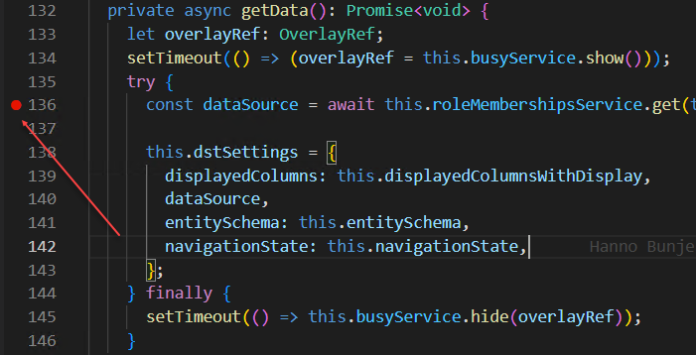

5. Start debugging as in StartDebugging.

Navigate to the page. Code will stop at the breakpoint.

6. Press F10 to step over next function to retrieve data from Api Server

In Variables window see “dataSource -> Data -> 0”

There is a list of columns below it. Turns out column “UID_UNSRoot” is already present. That is what we want to display. It points to the origin of the System entitlement.

I assume here that this column will bring a display value of the UNSRoot, not the actual ID when displayed in the table.

7. Stop debugging by either closing the browser or clicking on Stop (Shift+F5)

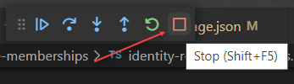

Modify

To display data in imx-membership-table (see .html file) we need to pass the following information to it:

displayedColumns - Array of columns to display (To limit which data columns, returned from ApiServer, will be displayed)

dataSource – Data to be displayed

entitySchema – description of all columns related to the data. (Retrieved from ApiServer)

navigationState

1. Add an additional “Display column” to tell a display component to display an extra column.

In identity-role-memberships.component.ts in the constructor under this.displayColumns array add **first** element:

{ ColumnName: "UID_UNSRoot", Display: "Target System", IsReadOnly: true, Type: ValType.String },

OR

this.entitySchema.Columns.UID_UNSRoot,

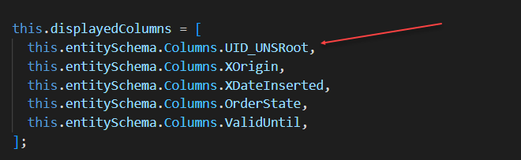

See how in terminal code starts recompiling as soon as changes are saved.

2. Run in debug mode again. See a new column appear. But the header of the column is UID_UNSRoot.

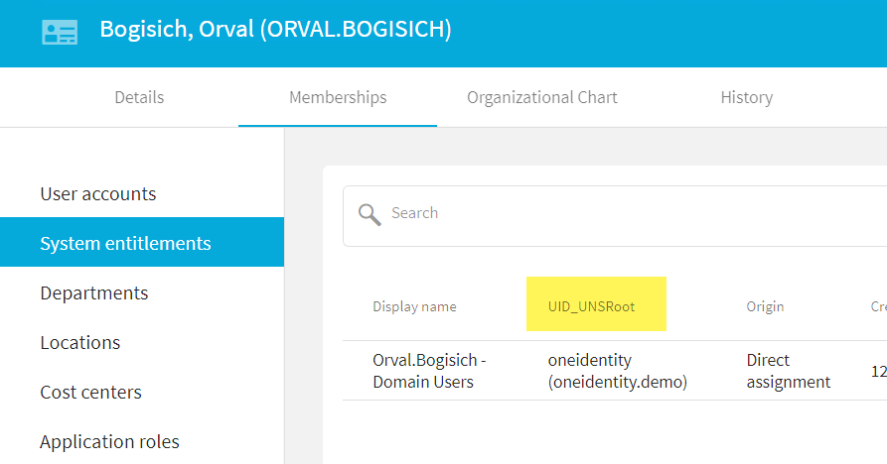

To fix that we need to change a display name of the UID_UNSRoot column in the entitySchema.

3. Add this line of code before specifying displayColumns:

this.entitySchema.Columns["UID_UNSRoot"].Display="Target System"

Or

this.entitySchema.Columns.UID_UNSRoot.Display = "Target System"

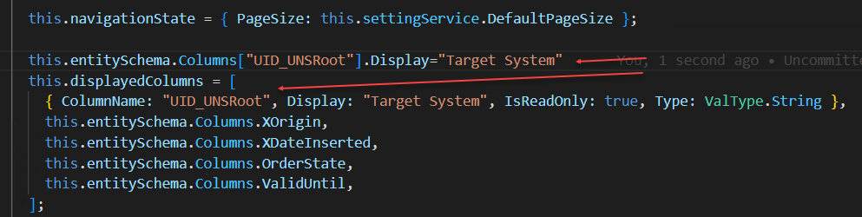

Or

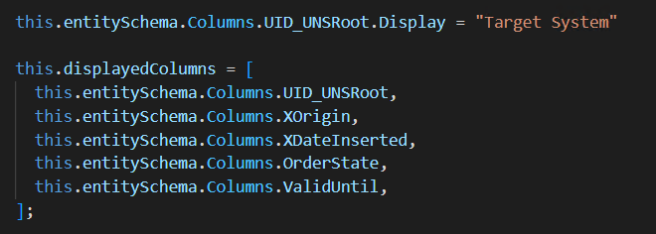

4. Run in debug mode again. Now extra column looks good.

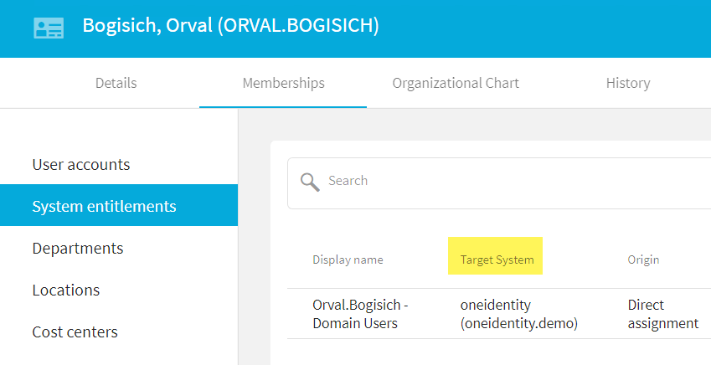

5. One last step. To protect from an error we should check if UNI_UNSRoot column is present in the entitySchema before trying to display it.

Add if statement before assigning a Display name to this column:

if(this.entitySchema.Columns["UID_UNSRoot"] != null){

and if it doesn’t exist – leave code as before:

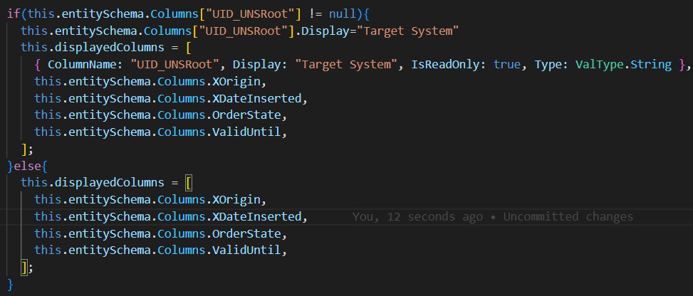

Deploy

Since this code belongs to the “qer” module and this module is “static” – **we**

**don’t need to deploy it**. But we need to recompile and deploy applications

and modules which depend on this module.

In this case it is just a Web Portal application.

1. Stop debugging.

Terminate batch jobs: In every open terminal press Ctrl+C, reply Y to question Terminate batch job (Y/N)?

2. In terminal window run command: npm run build:app qer-app-portal

The result will appear in the \imxweb\dist folder

3. Open folder \imxweb\dist\qer-app-portal.

Delete folder \html

Using 7-Zip, zip content of the folder and give it a name “Html_qer-app-portal.zip”

4. Move zip file to the folder C:\inetpub\wwwroot\ApiServer\bin\imxweb\custom

**Original file can remain in the** C:\inetpub\wwwroot\ApiServer\bin\imxweb folder

5. Run iisreset

6. Navigate to the Web Portal running on IIS and see that new column is there.

2. Add column 2 – Business Roles Membership

Find module to work on

Need to add a column which shows the full path for business role on the membership tab.

To get to this page select a direct report of logged in user, select “Membership” tab and select a “Business roles” menu.

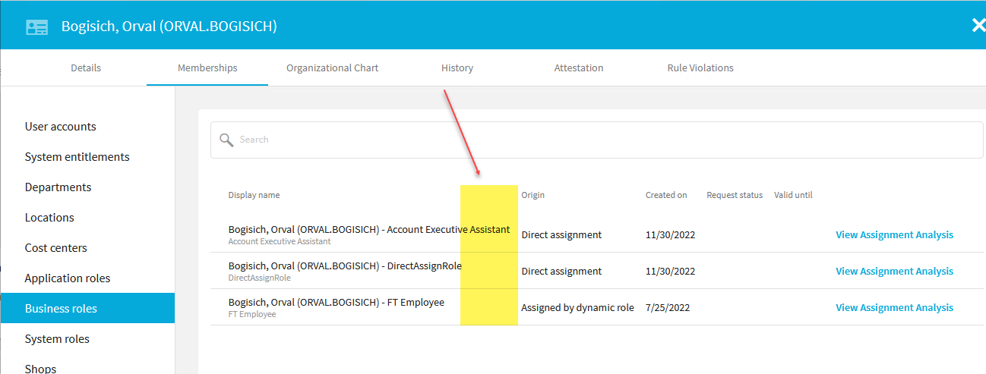

1. Right click on the name, click “Inspect” on the pop-up menu.

Find “identifiable” identifier above the inspect point.

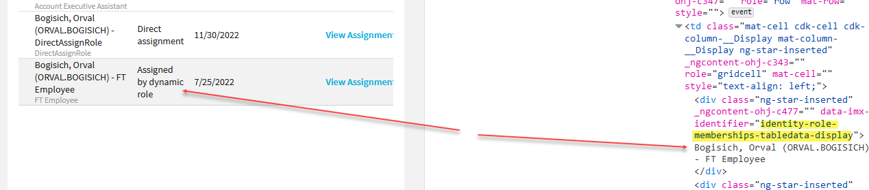

It looks the same as in “Add Column 1”

2. We know that it is module “qer” and component – identity-role-memberships.component.ts

Start debugging

1. In VS Code open a terminal and run command: npm run build:watch:dynamic rmb

If we don’t run this component, menu “Business roles” will not appear in the “Membership” tab of the person’s data window.

2. Open another terminal and run command: npm run build:watch qer

3. Open another terminal and run command: npm run start qer-app-portal

4. Start debugging as in "Start Debugging".

Navigate to the page. Code will stop at the breakpoint.

5. If code execution stopped on const dataSource = await this.roleMembershipsService.get(,

Press F10 to step over this function to retrieve data from Api Server

In Variables window see “dataSource -> Data -> 0 -> entity -> columns”

There is a list of columns below it. Column “RoleFullPath” is already present.

That is what we want to display. It points to the origin of the Business Role.

Also check the value of “dataSource -> Data -> 0 -> entity -> TypeName”

It is “PersonInOrg”.

7. Stop debugging by either closing the browser or clicking on Stop (Shift+F5)



Modify

1. We already have customizations from previous chapter. We just need to add another column checking if this specific column exists in the entitySchema or if entity is of the specific type:

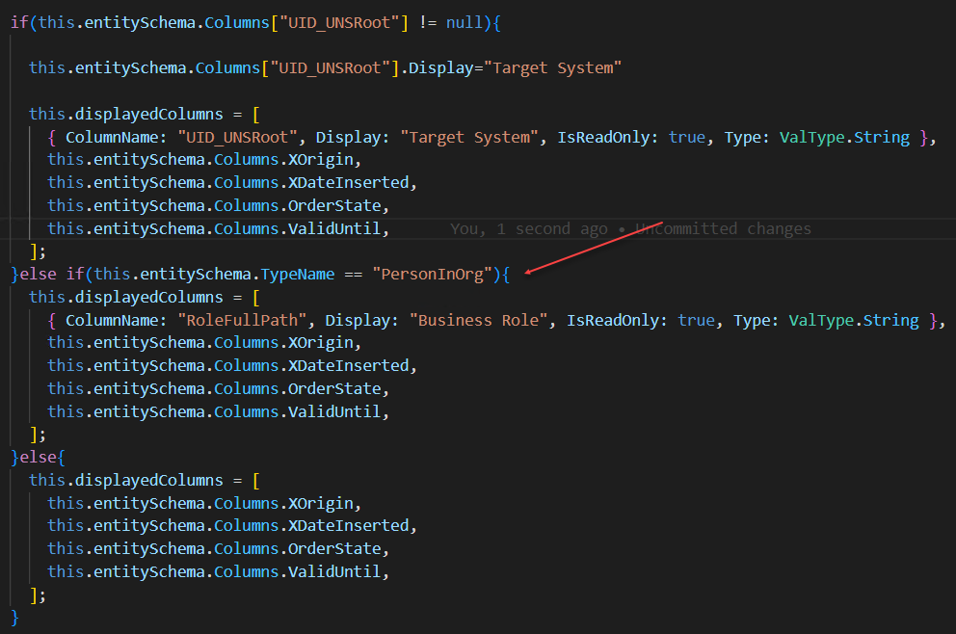

Or

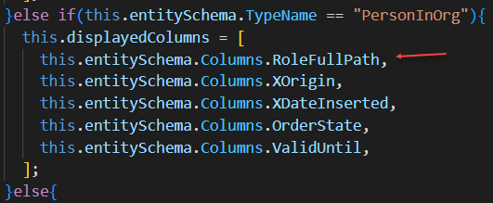

}else if(this.entitySchema.TypeName == "PersonInOrg"){

this.displayedColumns = [

this.entitySchema.Columns.RoleFullPath,

this.entitySchema.Columns.XOrigin,

this.entitySchema.Columns.XDateInserted,

this.entitySchema.Columns.OrderState,

this.entitySchema.Columns.ValidUntil

];

}else{

2. Run in debug mode again.

Navigate to page, view extra column present:

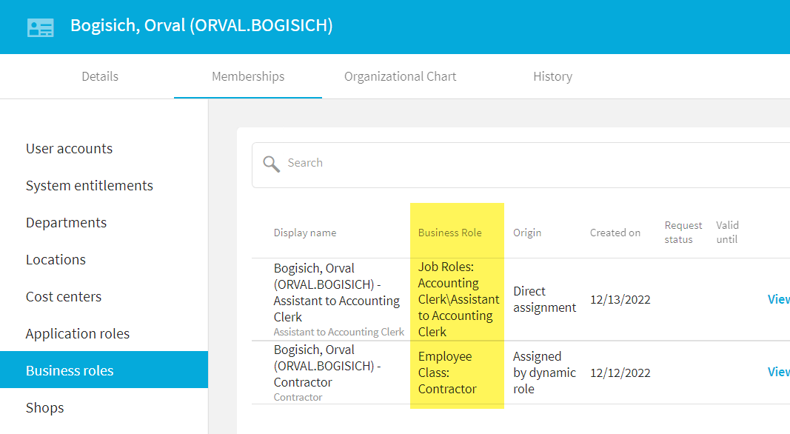

Deploy

Same as in Deploy in Add Column 1

3. Add column 3 – User Accounts Membership

This one is complicated. The column we need to add is not returned from the API call.

So, we need to find the way to return this column from API, modify client to make that call and receive extra column.

Find module to work on

Need to add a column which shows whether account is active or not.

To get to this page select a direct report of logged in user, select “Membership” tab, and select a “User Accounts” menu.

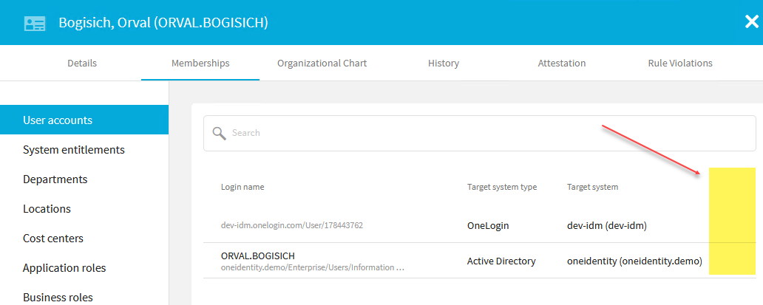

1. Right click on the name, click “Inspect” on the pop-up menu.

Find “identifiable” identifier above the inspect point.

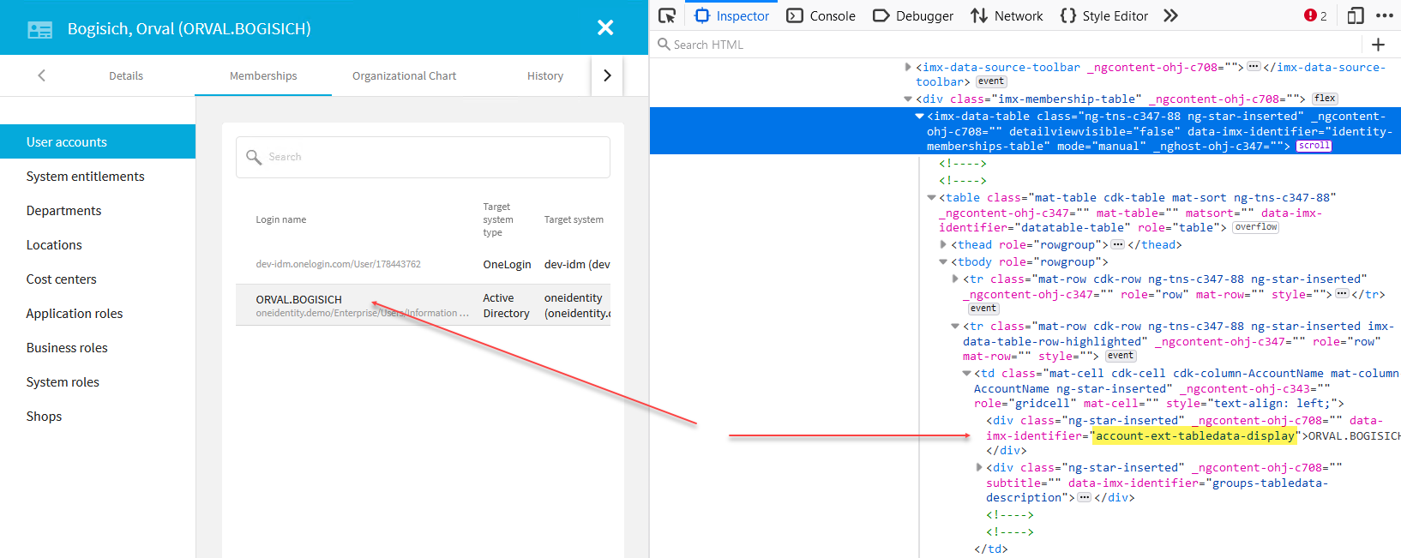

2. Paste the name from #1 into the search in VS Code.

See the results. There are multiple results, but they all located in the same file: accounts-ext.component.html

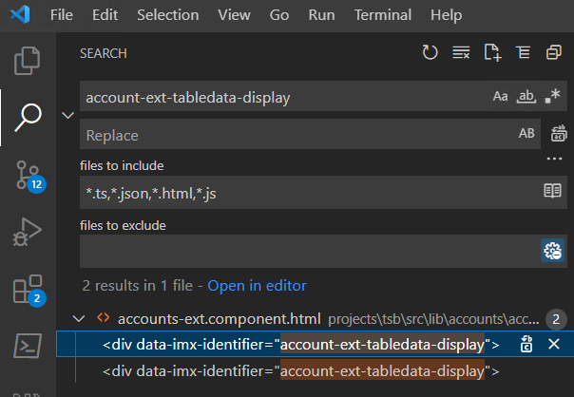

3. Double click on the result. Corresponding .html file opens.

Click on the “Explorer” tab in VS Code.

Project tree opens with selected html file highlighted.

Select .ts file (component) with the same name as html file:   
accounts-ext.component.ts

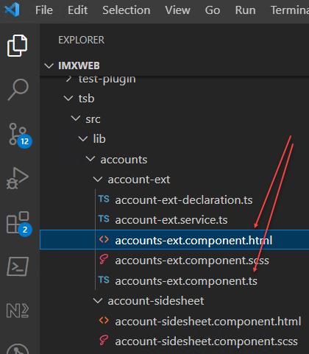

4. See what module selected html file belongs to.

In this case it is “tsb”.

Start debugging

1. In VS Code open a terminal and run command: npm run build:watch:dynamic tsb

Wait until compiles with no errors.



2. Open another terminal and run command: npm run start qer-app-portal

3. Set a breakpoint in file accounts-ext.component.ts function getData()

To see what kind of data we get from Api Server.

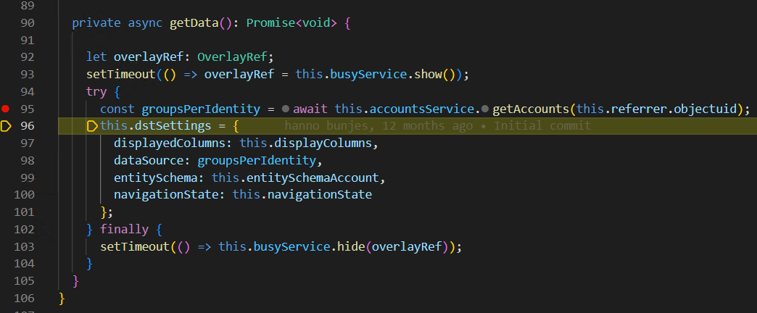

5. Start debugging as in StartDebugging.

Navigate to the page. Code will stop at the breakpoint.

6. Press F10 to step over next function to retrieve data from Api Server

In Variables window see “groupsPerIdentity -> Data -> 0”

There is a list of columns below it. Column “AccountEnabled” or “AccountDisabled” is not in the list.

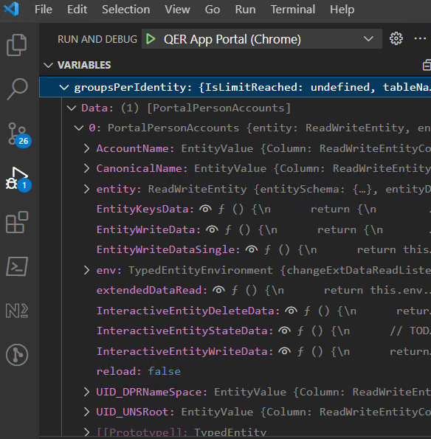

7. Stop debugging by either closing the browser or clicking on Stop (Shift+F5)



Research ApiServer method

We need to check if the API method, used to retrieve data can retrieve information on account being enabled. Also need to figure out what needs to be done to retrieve that information.

1. In VS Code find a method name which is used to retrieve accounts for the user.

In accounts-ext.component.ts , method getData() right click on this.accountService.**getAccounts** and select Go To Definition.

It takes us to the account-ext.service.ts function getAccounts(). And there we can see a call to this.apiService.typedClient.PortalPersonAccounts.Get(uid)

We can make it more precise, but here we get enough information to assume that API method will have portal, person, and accounts in the name.

2. Open browser, go to swagger: <http://localhost:8182/html/qbm-app-landingpage/#/swagger-ui>

Log in as in API Login

Type “accounts” in search window. First method that comes up is:

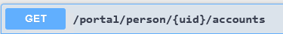

3. Click on “Try it out”.

Type “1003” (Ben Erdman) to “uid” field

Click “Execute”, view results:

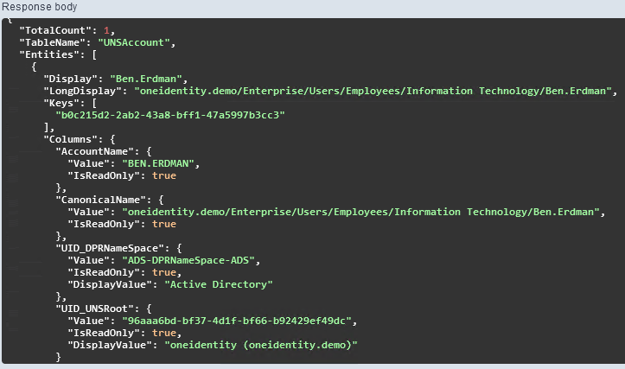

Table name – “UNSAccount”

Returned columns – “AccountName”, “Canonical Name”, “UID_DPRNameSpace”, “UID_UNSRoot”

UNSAccount table contains field AccountDisabled – that’s what we need.

4. In swagger, method GET /portal/person/{uid}/accounts , in the field withProperties type AccountDisabled , execute method and view the result.

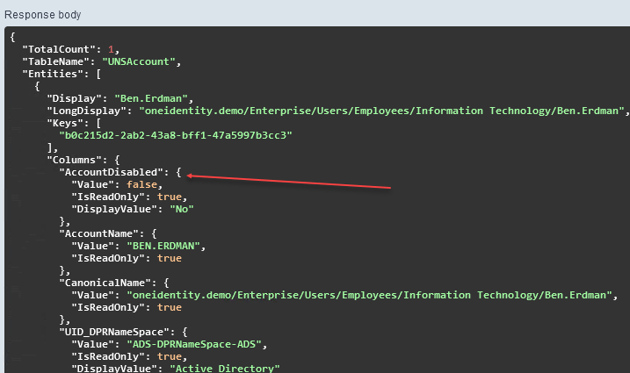

This is what we need.

Modify

1. Need to change a method in the component that calls API. We need to be able to pass the name of an additional column name to it.

In accounts-ext.component.ts method getData() :

replace line: const groupsPerIdentity = await this.accountsService.getAccounts(this.referrer.objectuid);

with line: const groupsPerIdentity = await this.accountsService.getAccountsWithExtraColumns( this.referrer.objectuid, "AccountDisabled");

2. Switch to account-ext.service.ts and add method getAccountsWithExtraColumns()

3. Add additional column to account-ext.component.html.

4. There is a lot of code goes into this modification.

Find full code of the following files in folder \UNITE\Chapter Files\3. Add column 3 …\Modified

accounts-ext.component.ts

accounts-ext.component.html

account-ext.service.ts

account-ext-declaration.ts

Please compare this code with the original code in folder \UNITE\ Chapter Files\3. Add column 3…\Original

To do so use Notepad++ with Compare plugin.

I had to add all this code because of the following reasons:

1. Lack of experience

2. Fact that most objects are read only, and I can’t just add an extra column or value. Had to create separate classes to hold extra information.

If someone comes up with simpler way to accomplish this task – please let me know.

3. Replace code. Run code as in Start Debugging

View result:

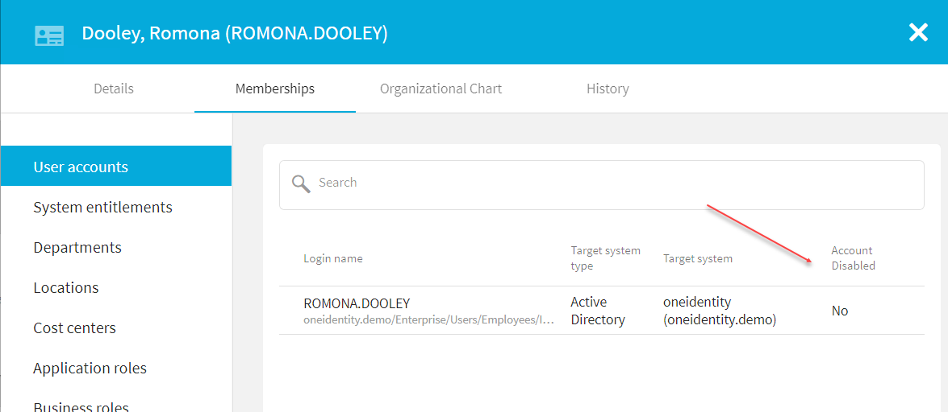

Deploy

Since this code belongs to the “tsb” module and this module is “dynamic” – we need to deploy it.

1. Stop debugging.

Terminate batch jobs: In every open terminal press Ctrl+C, reply Y to question

Terminate batch job (Y/N)?

2. In terminal window run command: npm run build:lib tsb

The result will appear in the \imxweb\dist folder

3. Open folder \imxweb\dist\tsb.

Using 7-Zip, zip content of the folder and give it a name “Html_tsb.zip”

4. Move zip file to the folder C:\inetpub\wwwroot\ApiServer\bin\imxweb\custom

Original file can remain in the C:\inetpub\wwwroot\ApiServer\bin\imxweb folder

5. Run iisreset

6. Navigate to the Web Portal running on IIS and see that new column is there.

4. Add “Terminate” button

Need to add a big red “Terminate” button to the slide panel, which opens up when a user clicks on “My Direct Reports” record.

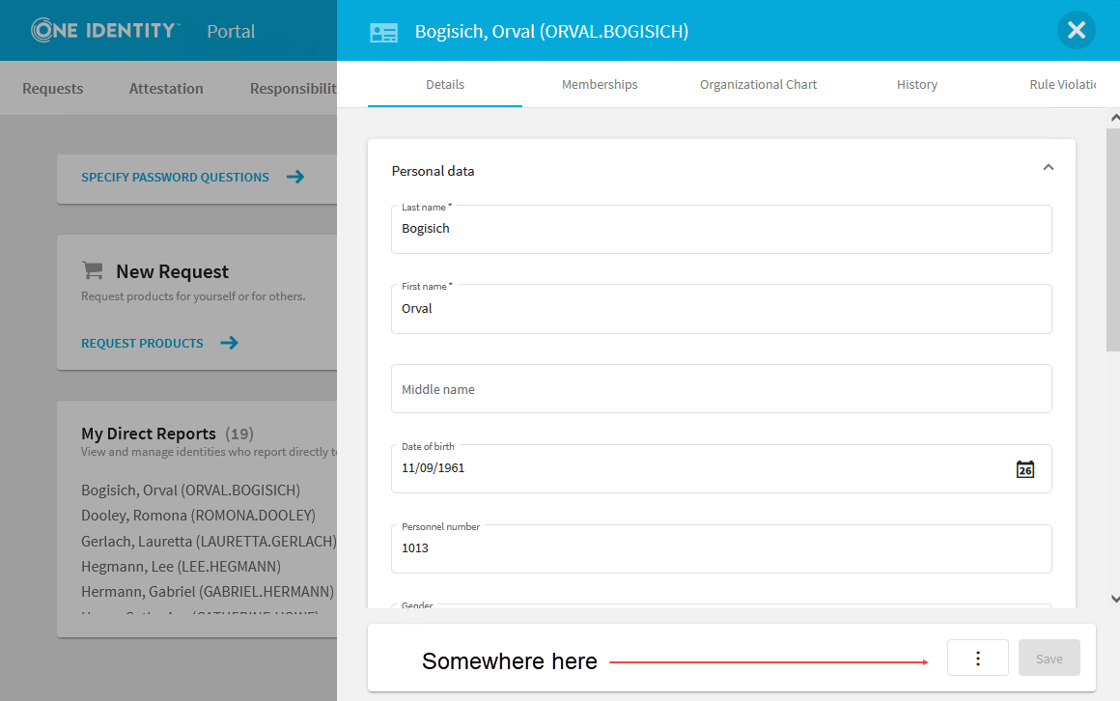

Find module to work on

To get to this page select a direct report of logged in user to open a side panel.

1. Right click on three dot menu as in picture above. Select “Inspect”

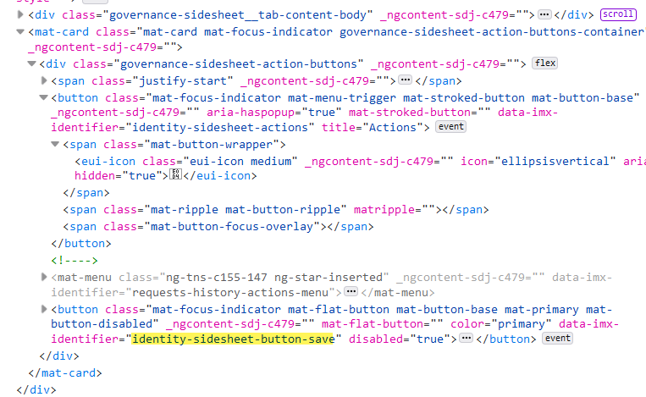

2. In VS Code do a search on identity-sidesheet-button-save

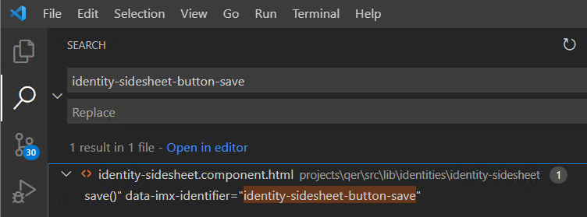

3. Double click. identity-sidesheet.component.html opens.

And the module is – “qer”

Start debugging

1. In VS Code open a terminal and run command: npm run build:watch qer

Wait until compiles with no errors.

2. Open another terminal and run command: npm run start qer-app-portal

3. Start debugging as in StartDebugging.

Navigate to the page. There is still no red button.

Modify

If you don’t want to go step-by-step -there is a complete code in the folder

\UNITE\Chapter Files\4. Add Terminate Button\Modified

1. In identity-sidesheet.component.html see a Save button

It is located inside mat-card, after mat-menu (that button with 3 dots)

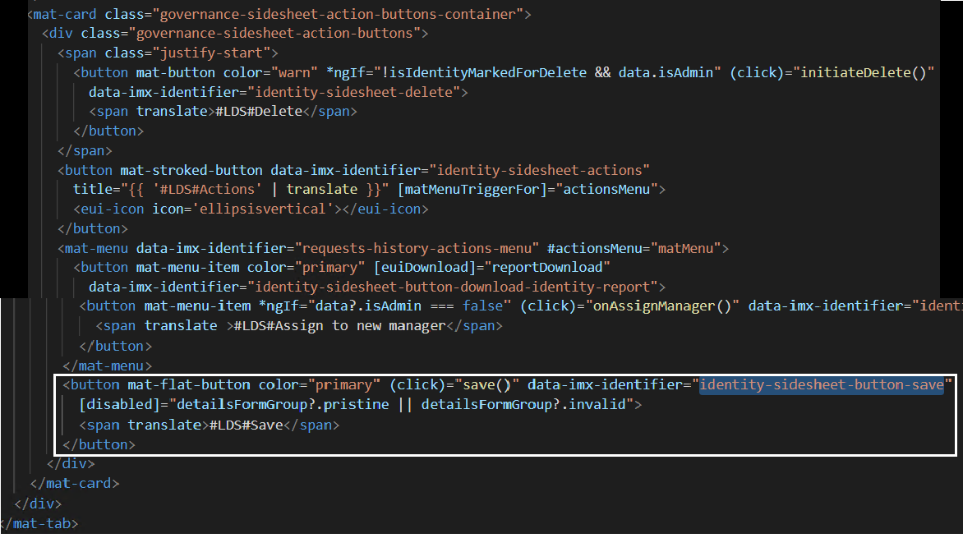

On click event it runs function “save()”

2. Add another button right above Save button so it will be located between menu and Save button:

<!--New Terminate button-->

<button

mat-flat-button

color=**"warn"**

(click)=**"terminate()"**

data-imx-identifier="identity-sidesheet-button-terminate">

<span translate >#LDS#Terminate</span>

</button>

I assume that color=”warn” will add some shade of red to the button.

3. Create a method “terminate()” in identity-sidesheet.component.ts   
 Use method “Save()” as an example.  
 Main line is this: await this.data.selectedIdentity.GetEntity().Commit(true);

This is how we save current identity data after all changes.

In order to terminate an identity we need to set value “IsInActive” to true.  
This is how we’ll do it: this.data.selectedIdentity.IsInActive.value = true;

4. Complete function code. It also includes pop-up asking user if he’s sure to terminate:

public async terminate(): Promise<void> {

var ent = this.data.selectedIdentity.GetEntity()

**if** **(await** **this.**confirmationService**.confirm({** Title**:** '#LDS#Terminating Identity'**,**

Message**:** '#LDS#Are you sure you want to terminate ' **+** ent**.**GetColumn**(**"CentralAccount"**).**GetValue**()** **+** '? '

**}))**

**{**

**if** **(this.**detailsFormGroup**.**valid**)** **{**

**this.**logger**.**debug**(this,** `Terminating identity`**);**

**const** overlayRef **=** **this.**busyService**.**show**();**

**try** **{**

this.data.selectedIdentity.IsInActive.value = true;

**await** ent**.**Commit**(true);**

**this.**detailsFormGroup**.**markAsPristine**();**

**this.**snackbar**.open({** key**:** '#LDS#User ' **+** ent**.**GetColumn**(**"CentralAccount"**).**GetValue**()** **+** ' was terminated' **});**

**this.**closeSidesheet**();**

**}** **finally** **{**

**this.**busyService**.**hide**(**overlayRef**);**

**}**

**}**

**}**

**}**

5. Run in debug mode again. See new button.

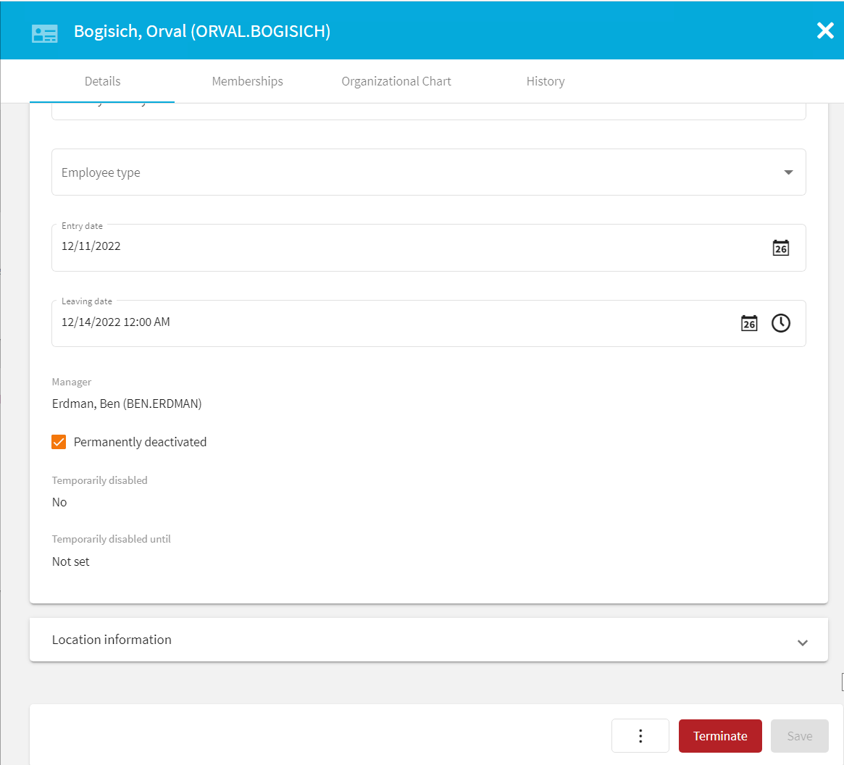

6. Click on button. Refresh form and see that person is permanently deactivated.

But the button is still saying “Terminate”. And we can probably terminate this user again.

Now it would be nice to for the button to change text to “Unterminate” if user is already terminated and also be able to do “Untermination”

7. Add button “Unterminate” to the identity-sidesheet.component.html

Add “*ngIf” statement to both “Terminate” and “Unterminate” buttons.

This statement will check if currently selected identity is terminated and will display either “Terminate” button or “Unterminate” button

<button

mat-flat-button

color=**"warn"**

*ngIf="!data?.selectedIdentity?.IsInActive.value"

(click)=**"terminate()"**

data-imx-identifier="identity-sidesheet-button-terminate">

<span translate >#LDS#Terminate</span>

</button>

<button

mat-flat-button

color=**"primary"**

*ngIf="data?.selectedIdentity?.IsInActive.value"

(click)=**"unTerminate()"**

data-imx-identifier="identity-sidesheet-button-terminate">

<span translate >#LDS#Re-enable</span>

</button>

Check the difference in “*ngIf” statements and color and text of the buttons.

8. Add method “unterminate()” to identity-sidesheet.component.ts . The only difference with Terminate method is setting value of IsInActive to false

**public** **async** unTerminate**():** Promise**<void>** **{**

**if** **(this.**detailsFormGroup**.**valid**)** **{**

**this.**logger**.**debug**(this,** `Terminating identity`**);**

**const** overlayRef **=** **this.**busyService**.**show**();**

**try** **{**

**this.**data**.**selectedIdentity**.**IsInActive**.**value **=** **false;**

**var** ent **=** **this.**data**.**selectedIdentity**.**GetEntity**()**

**await** ent**.**Commit**(true);**

**this.**detailsFormGroup**.**markAsPristine**();**

**this.**snackbar**.open({** key**:** '#LDS#User ' **+** ent**.**GetColumn**(**"CentralAccount"**).**GetValue**()** **+** ' was re-enabled' **});**

**this.**closeSidesheet**();**

} finally {

**this.**busyService**.**hide**(**overlayRef**);**

**}**

**}**

**}**

9. View Re-enable button, click on it and verify results.

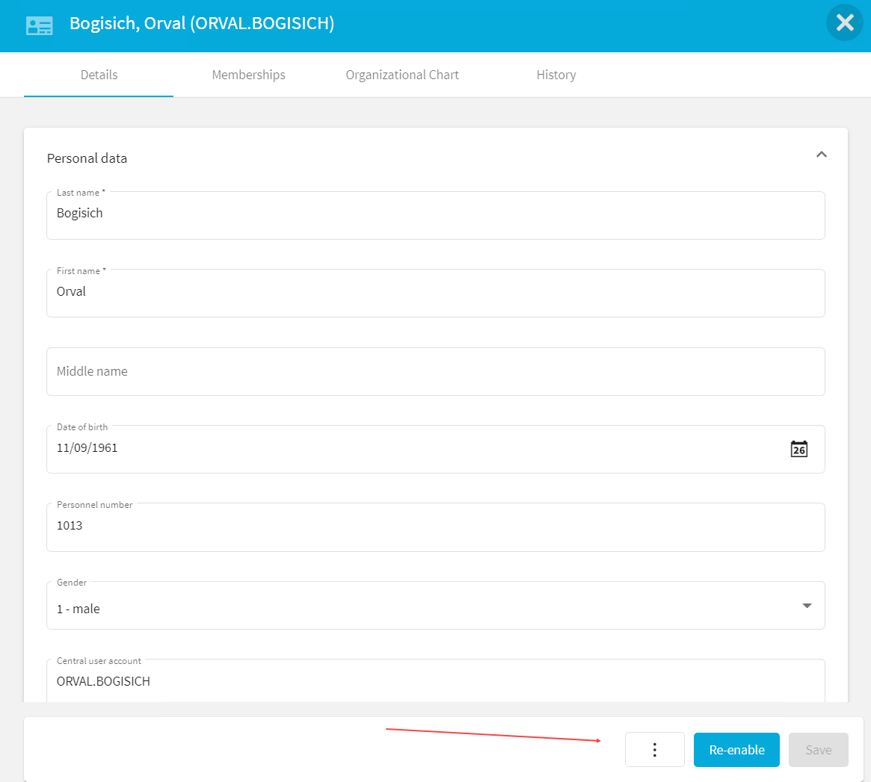

Deploy

Same as in Deploy in Add Column 1

5. Add base plugin component

Here we’ll add a simple custom plugin component with minimum functionality.

It will be presented to users as a tile on the main Welcome page, display the name of the logged in user and open a message box on click.

Generate a new component

1. In VS Code click on NX Concole -> Generate -> Select “library” from dropdown.

Change values as in pictures below and click “Run”.

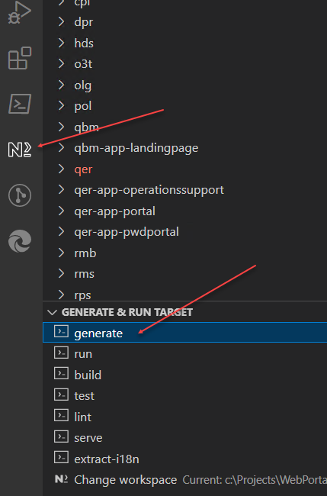

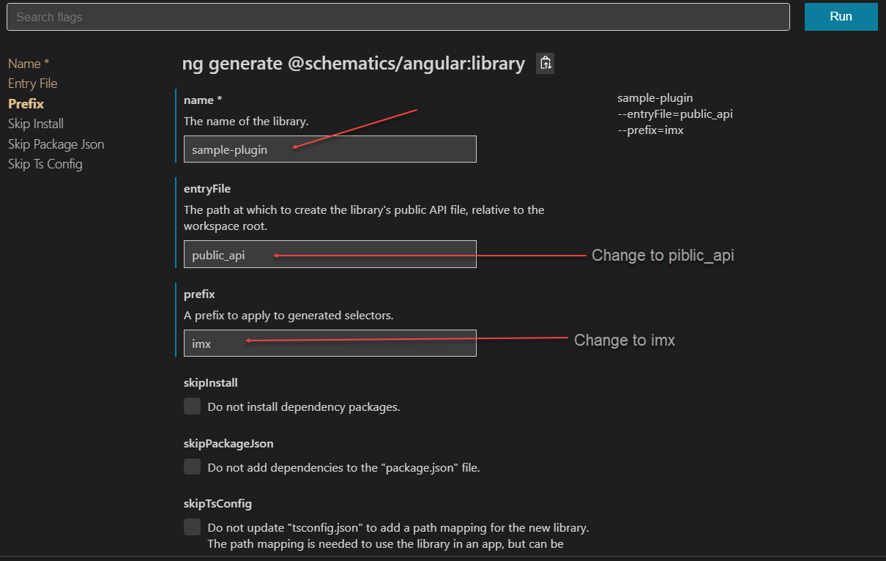

List of files to add/modify (they can be copied from rmb or rms projects and modified):

* imx-project.json
* imx-plugin-config.json
* ng-package.json
* ng-package.dynamic.json
* package.json
* tslint.json
* tsconfig.lib.prod.json
* IMXWEB/angular.json
* IMXWEB/tsconfig.json

In all files, <project-name> needs to be replaced with “name of the library” you selected when generating this library. In this case it is “sample-plugin”

2. Edit file IMXWEB\angular.json. Node <project-name> must already be there.

Under <project name>->architect->build->configurations add:

"dynamic": {

"project": "projects/<project-name>/ng-package.dynamic.json"

}

Under <project name>->architect->build->options add:

"tsConfig": "projects/<project-name>/tsconfig.lib.json"

Also - change "prefix": "lib" to "prefix": "imx"

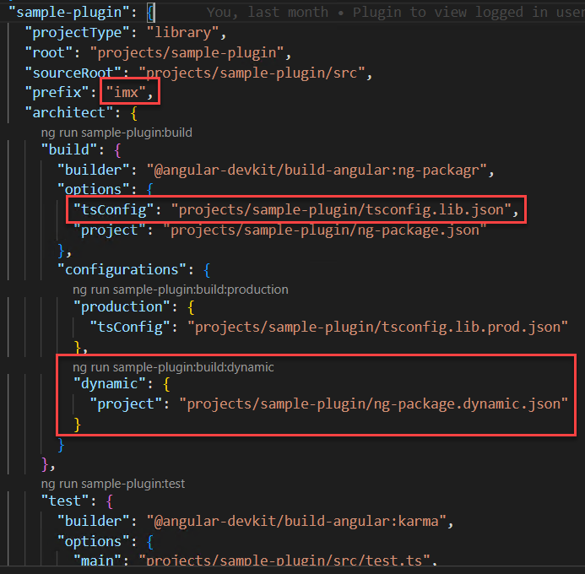

3. Create file sample-plugin-demo/ng-package.dynamic.json.

Copy it from rmb or rms projects and modify line

"dest": "../../html/rmb", to "dest": "../../html/<project-name>",

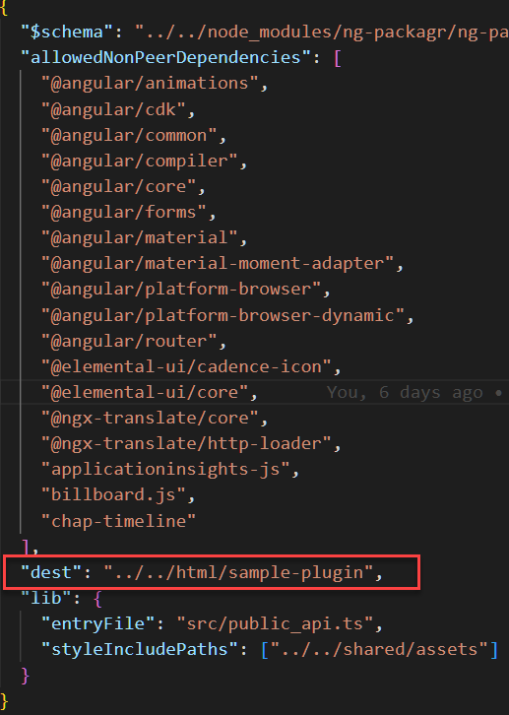

4. Create file <project-name>/imx-project.json (copy from "rms" and change “rms” to “<project-name>”)

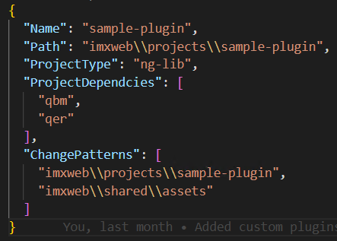

5. Modify file IMXWEB\tsconfig.json. Make entry for <project-name> look the same as for any other entries. Add line:

"<project-name>/*": [

"dist/<project-name>/*"

],

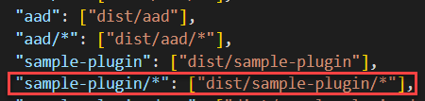

6. Change file name <project-name>/src/public-api.ts to <project-name>/src/public_api.ts

7. ng-package.json – replace "entryFile": "src/public-api.ts" with "entryFile": "src/public_api.ts

8. Copy file “tslint.json” from rms/rmb

9. Create file “imx-plugin-config.json” – Copy from “rps” and change.

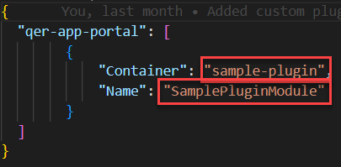

Get “Name” from file <project-name>/src/lib/<project-name>.module.ts ,

From the line “export class SamplePluginModule”

10. Create folder:

"C:\Program Files\One Identity\One Identity Manager\imxweb\Html_<project-name>"

1. Copy file “imx-plugin-config.json” to folder “Html_<project-name>” from 10.

This folder and file will help Angular to load this library dynamically unto the portal.

12. Check file tsconfig.lib.prod.json

**Remove line** "compilationMode": "partial" **from** angularCompilerOptions **!!!**

Add line "enableIvy": true

{

"extends": "./tsconfig.lib.json",

"compilerOptions": {

"declarationMap": false

},

"angularCompilerOptions": {

"compilationMode": "partial",

"enableIvy": true

}

}

Modify Code

Steps to register new component as a Tile and run some code on tile click:

All final source code is in the \UNITE\Chapter Files\5. Add base plugin component folder.

Sample-plugin.module.ts

1. Open file “<project name>\src\lib\<project name>.module.ts”

2. Add constructor inside the class definition:

**export** **class** SamplePluginModule **{**

**constructor(private** readonly initializer**:** SamplePluginService**)** **{**

console**.**log**(**'In constructor of SamplePluginModule.'**);**

**this.**initializer**.**onInit**();**

console**.**log**(**'SamplePluginModule initialized'**);**

**}**

}

3. To resolve dependencies - hover mouse pointer over “SamplePluginService” , click on “Quick Fix…” in pop-up

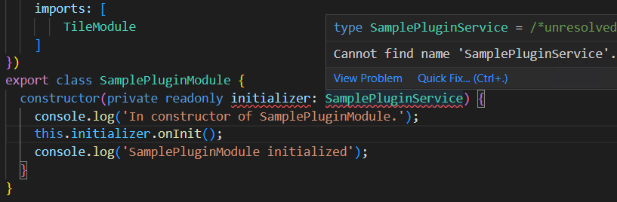

Select “Add import from “./sample-plugin.service”

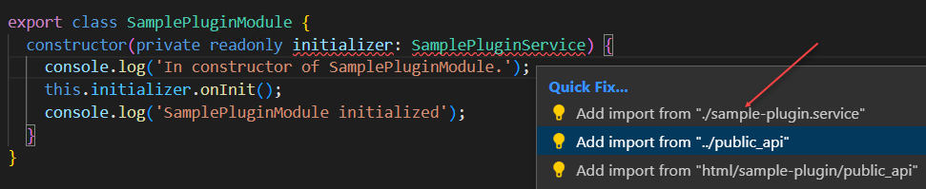

4. In the constructor there is a parameter:

constructor(private readonly initializer: SamplePluginService)

It is an instance of the SamplePluginService and it is being passed to the module by Angular framework.

5. Under @NgModule -> imports add TileModule

Constructor has a code, calling that service’s onInit() method, which will execute the initialization code in the Service:

this.initializer.onInit();

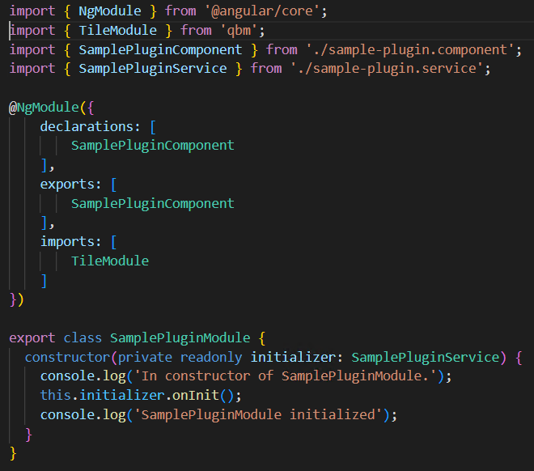

sample-plugin.service.ts

1. Add constructor to the SamplePluginService:

ExtService is used to register a component as a Tile on the dashboard

constructor(

private readonly extService: ExtService

) { }

2. Add “onInit()” function to the sample-plugin.service.ts inside class SamplePluginService declaration.

public onInit(): void{

**this.**extService**.**register**(**'Dashboard-SmallTiles'**,** **{**instance**:** SamplePluginComponent**})**

}

Here we can see a line that registers this module as a Tile.

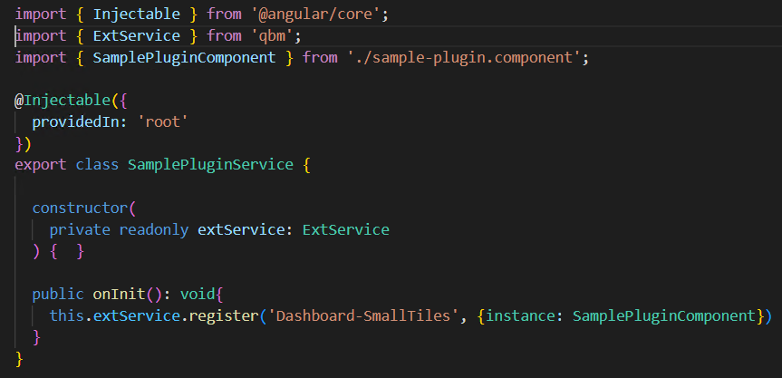

Sample-plugin.component.html

1. In VS Code -> Explorer right click on “lib” folder in \projects\<project name>\src\

Select “New File”, enter name: sample-plugin.component.html

2. Add following HTML to the new file:

<imx-tile

[caption]=**"caption"**

[value]="description"

[actionText]=**"actionText"**

buttonColor=**"red"**

size="Addon-Tile"

(actionClick)="doOnClickOperation()"

>

</imx-tile>

Values “caption”, “description” and “actionText” are properties in the SamplePluginComponent

Sample-plugin.component.ts

7. Modify @Component :

Remove “template”, add templateUrl: './sample-plugin.component.html'

8. Declare and assign properties in SamplePluginComponent right after

export class SamplePluginComponent implements OnInit

caption: string = "View Personal Information"

actionText: string = "";

description: string = "Logged in user can view his name"

9. Add constructor:

constructor(

public requestsService: RequestsService,

public readonly sessionService: imx_SessionService

) { }

RequestsService will be used here to open an “approved” message box,

imx_SessionService contains information about current session including a logged in username

10. Implement onInit() – log into console and retrieve logged in username

**async** ngOnInit**():** Promise**<void>** **{**

console**.**log**(**"SamplePluginComponent -> onInit"**)**

**this.**actionText **=** **(await** **this.**sessionService**.**getSessionState**()).**Username

**}**

11. Add function openIdentitySidesheet() :

**public** **async** doOnClickOperation**():** Promise**<void>** **{**

**this.**requestsService**.**openSnackbar**(**'Hello ' **+** **this.**actionText**,** '#LDS#Close'**);**

**}**

This function will just open a pop-up window.

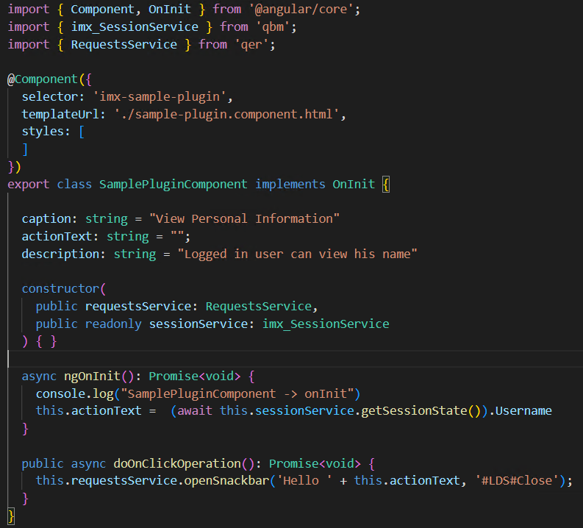

Debug component

1. In VS Code open a terminal and run command: npm run build:watch:dynamic sample-plugin

Wait until compiles with no errors.

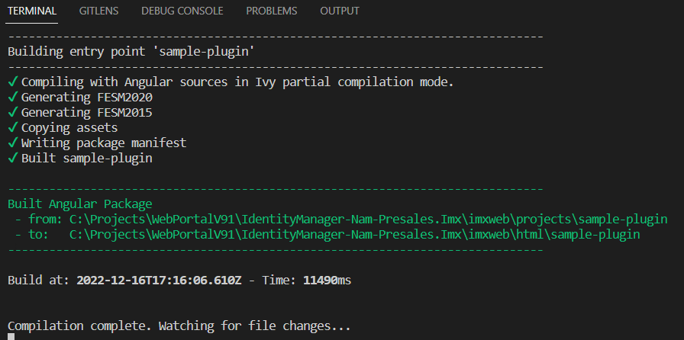

2. Open another terminal and run command: npm run start qer-app-portal

3. Start debugging as in "Start Debugging". View component with new tile.

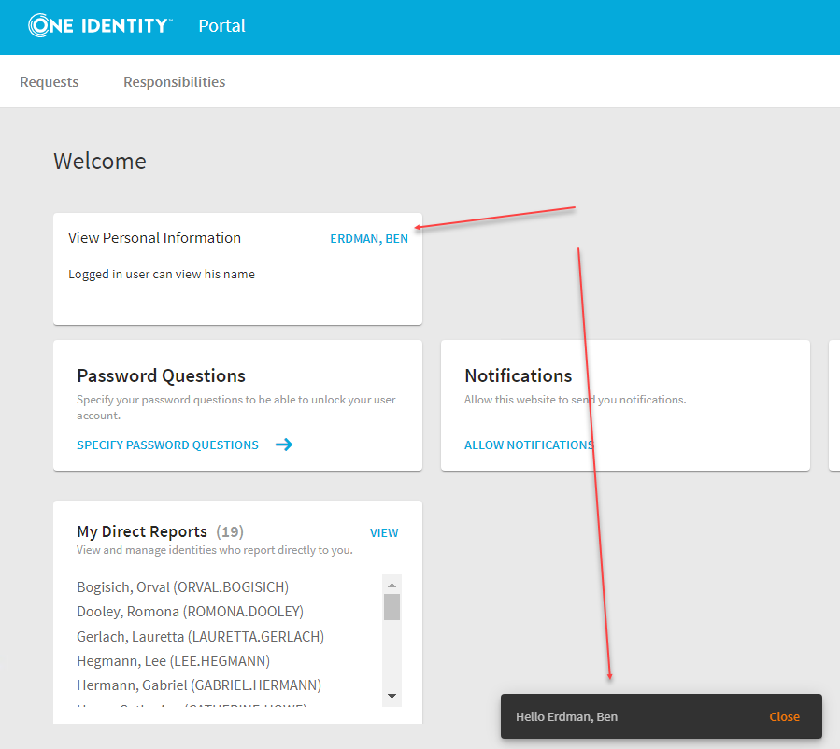

Deploy plugin component

Since this module is “dynamic” – we need to deploy it.

1. Stop debugging, terminate batch jobs.  
 Press ‘ctl+C’ in Terminal, then ‘Y’

2. In terminal window run command: npm run build:lib sample-plugin

The result will appear in the \imxweb\dist folder

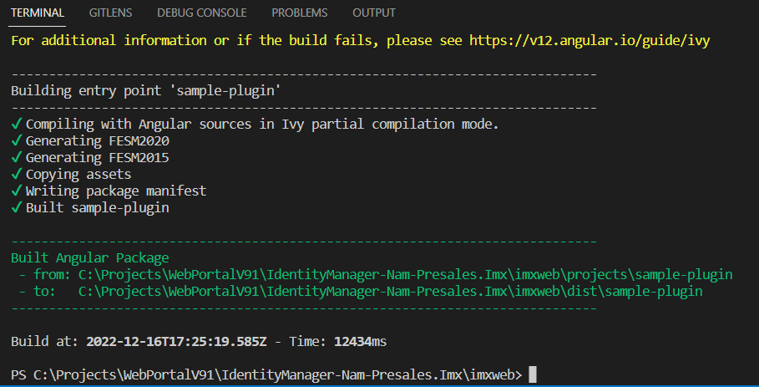

3. Open folder \imxweb\dist\sample-plugin.

Using 7-Zip, zip content of the folder and give it a name “Html_sample-plugin.zip”

4. Move zip file to the folder C:\inetpub\wwwroot\ApiServer\bin\imxweb\custom

Original file can remain in the C:\inetpub\wwwroot\ApiServer\bin\imxweb folder.

5. Create folder Html_sample-plugin in C:\inetpub\wwwroot\ApiServer\bin\imxweb folder, copy file imx-plugin-config.json there.

This will allow Web Portal to dynamically load sample-plugin component.

6. Run iisreset

7. Navigate to the Web Portal running on IIS and see that new tile is there.

Deployment errors

If plugin component tile does not appear on dashboard while it appears in debug mode, check following:

1. Clear browser data- cookies, site data, cached web content.

2. Check file tsconfig.lib.prod.json of the project:

{

"extends": "./tsconfig.lib.json",  
 "compilerOptions": {  
 "declarationMap": false  
 },

"angularCompilerOptions": {

"compilationMode": "partial”, à **Remove this line**

"enableIvy": true à **Make sure this line is present**

}

}

2. Check file package.json of the project - Remove everything but this:

{

"name": "<name>",

"version": "0.0.1",

"private": true

}

3. If error happens while running imxclient.exe run-apiserver -B

Delete everything from folder

C:\Users\<username>\AppData\Local\One Identity\One Identity Manager\ImxClient

4. Re-deploy.

6. Modify base plugin to display personal data

When user clicks on the tile, the slide panel opens with user’s personal information. Same as when user clicks on the “My Direct Reports” – individual direct report.

Research

To find a code involved in opening a slide panel with personal information – right click on one of the direct reports in “My Direct Reports” tile, select “Inspect”.

Find identifiable identifier, copy, and paste into VS Code search window.

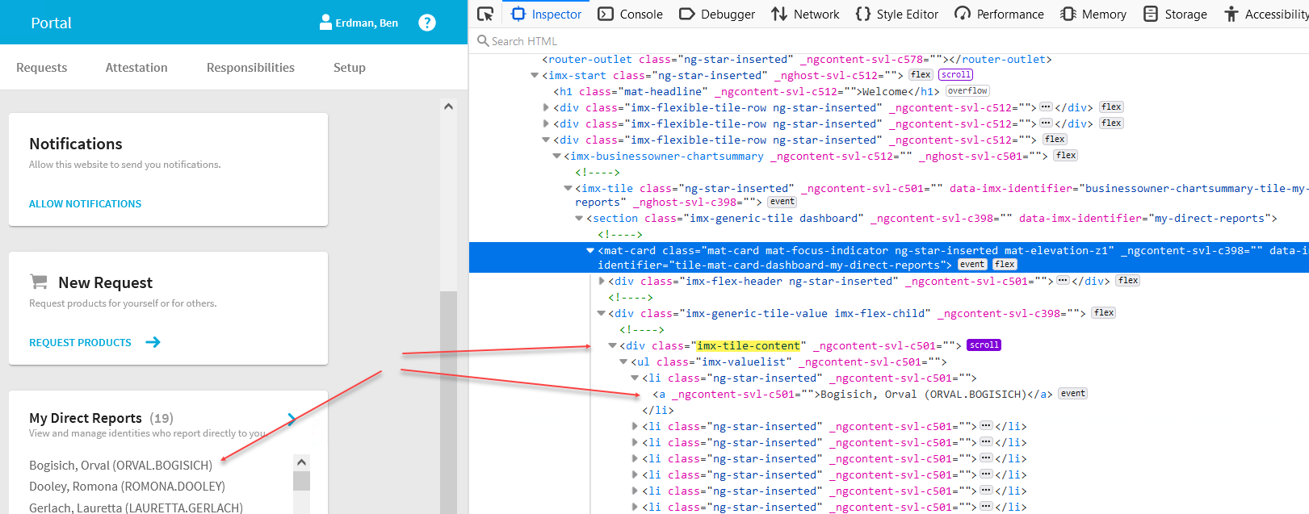

Search returns 2 values. One of them points to: (click)="openIdentitySidesheet(identity) in file businessowner-chartsummary.component.html

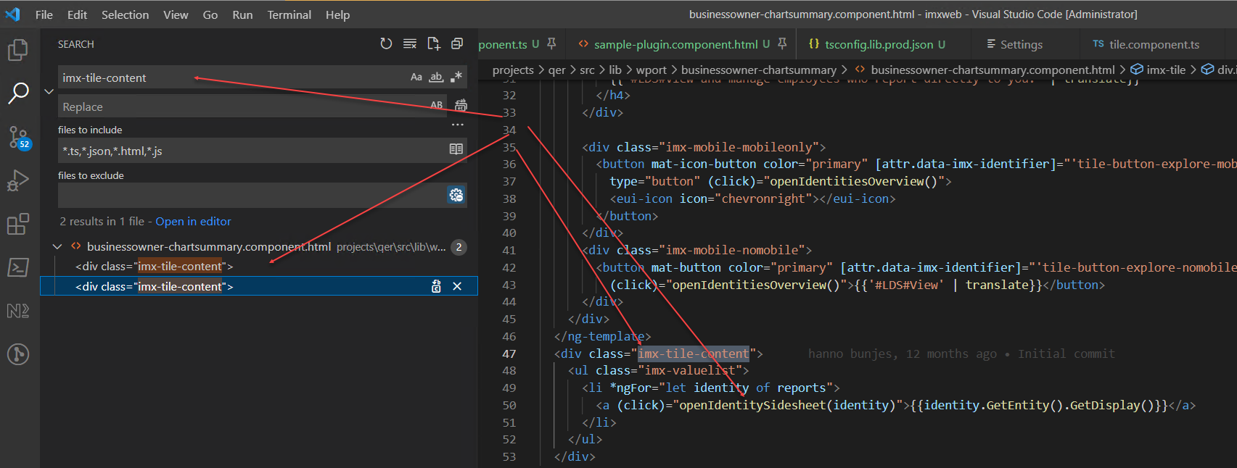

Switch to VS Code -> Explorer, select file with the same name and .ts extension, find function openIdentitySidesheet there.

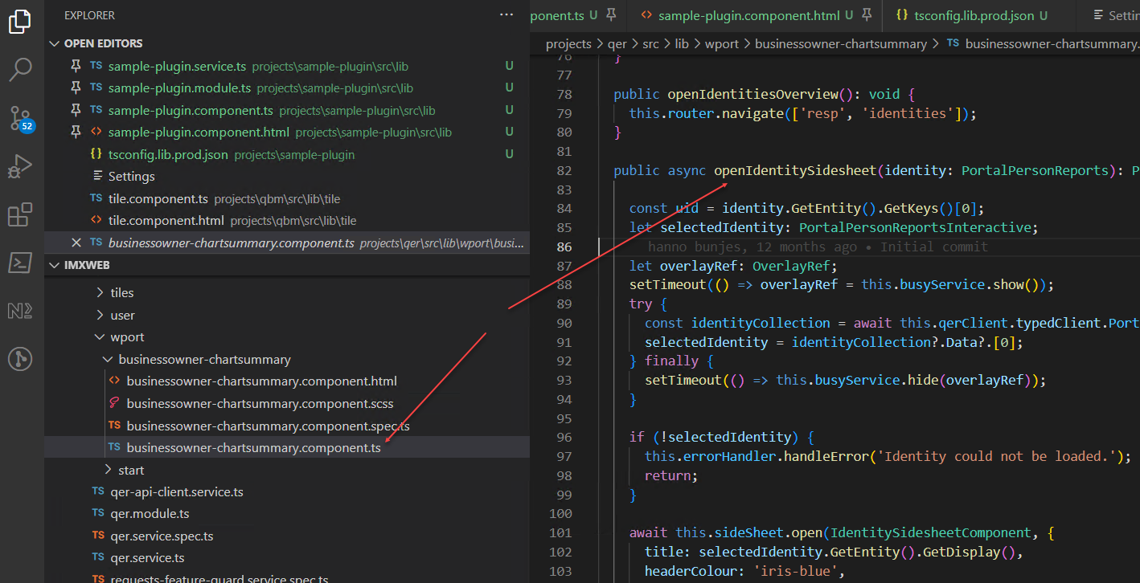

We can reuse this whole function, but with no parameter - just get an identity of the logged in user to it.

Also, we’ll reuse existing component to display data: IdentitySidesheetComponent from qer library. Just need to populate it with user’s personal data instead of direct report’s data. For that we’ll need to change and ApiServer call from PortalPersonReportsInteractive to PortalPersonMasterdataInteractive.

To modify the way the data is presented we can make a copy of IdentitySidesheetComponent inside the sample-plugin library and modify it.

Modify

All final source code is in the \UNITE\Chapter Files\6. Modify base plugin to display personal data folder

1. Copy function openIdentitySidesheet from file   
 businessowner-chartsummary.component.ts ,

Paste it to sample-plugin.component.ts and remove “identity” parameter.

We don’t need it since we can get the id of the logged in user from imx_SessionService

2. Comment out lines:

const uid = identity.GetEntity().GetKeys()[0];

and

await this.loadDirectReports();

3. Resolve reference errors.

4. Add following to the constructor:

private readonly busyService: EuiLoadingService,

private readonly qerClient: QerApiService,

private readonly errorHandler: ErrorHandler,

private readonly sideSheet: EuiSidesheetService,

private readonly configService: ProjectConfigurationService

5. Add declaration for projectConfig:

private projectConfig: ProjectConfig;

6. In ngOnInit() add line:

this.projectConfig = await this.configService.getConfig();

7. Add line var uid = (await this.sessionService.getSessionState()).UserUid before making call to retrieve the data. This will return uid of the logged in user, which we will use to retrieve a logged in person data.

8. Replace inside openIdentitySidesheet() function:

let selectedIdentity: PortalPersonReportsInteractive;   
 with  
 let selectedIdentity: PortalPersonMasterdataInteractive;

And

this.qerClient.typedClient.PortalPersonReportsInteractive.Get_byid(uid);

with

this.qerClient.typedClient.PortalPersonMasterdataInteractive.Get_byid(uid);

This call will retrieve logged in person’s master data from ApiServer

9. Modify sample-plugin.component.html – replace

(actionClick)="doOnClickOperation()"

with

(actionClick)=" openIdentitySidesheet()"

Debug

1. Start debugging like in Start Debugging Base Plugin Component

Run command npm run build:watch:dynamic sample-plugin to compile and run module in the debug mode.

2. Click on “View Personal Information” tile.

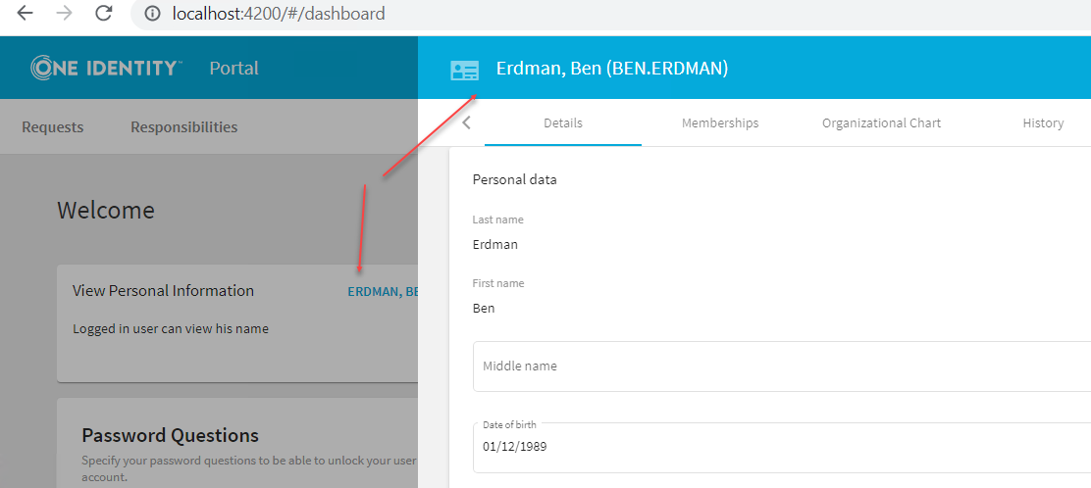

Deploy

Same as in Deploy in Add Column 1

Homework

See Add 'Terminate' Button. Make changes to hide “Terminate” button if user is viewing his personal data. When viewing report’s data the button should still appear.

7. Add custom plugin calling custom Api Server plugin

Here we’ll build a new plugin to display data, returned from a custom Api Server plugin.

All code is in the

**\UNITE\Chapter Files\7. Add custom plugin calling custom Api Server plugin\unite-plugin** folder.

Research

This module will call two different custom ApiServer methods returning the same data in two different formats.

Method 1: Uses script to retrieve data.

var ret = runner.Eval("CCC_Call_Database_Direct", parameters);

Data is returned in generic JSON format:

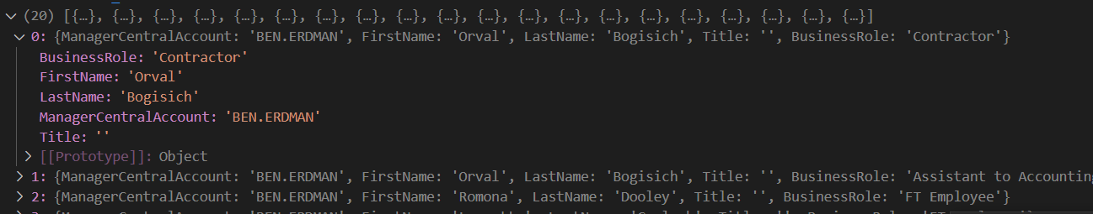

[{"ManagerCentralAccount":"BEN.ERDMAN",  
"FirstName":"Orval",  
"LastName":"Bogisich",  
"Title":"",  
"BusinessRole":"Contractor"},  
{"ManagerCentralAccount":"BEN.ERDMAN",  
"FirstName":"Orval",  
"LastName":"Bogisich",  
"Title":"",  
"BusinessRole":"Assistant to Accounting Clerk"}]

Method 2: Uses Predefined SQL to retrieve data –

HandleGetBySqlStatement("CCC_Get_Reports_With_Business_Roles", SqlStatementType.SqlExecute)

It returns data in predefined Identity Manager format:

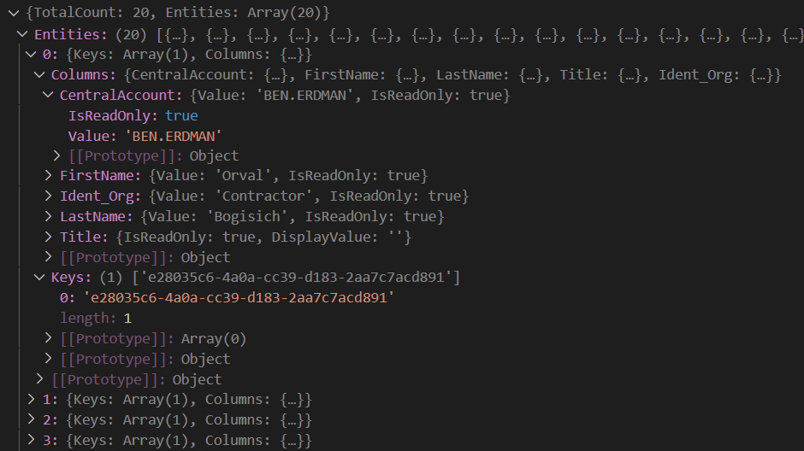

Build base component

1. Build new plugin components as in Add Base Plugin Component.

Here I used name unite-plugin. Or use pre-built component:

Complete code for base component is in the \UNITE\Chapter Files\7. Add custom plugin calling custom Api Server plugin\**initial** folder.   
It can be copied to the \imxweb\projects directory.   
To make it work:

* Add following section to **angular.json**:

"unite-plugin": {

"projectType": "library",

"root": "projects/unite-plugin",

"sourceRoot": "projects/unite-plugin/src",

"prefix": "imx",

"architect": {

"build": {

"builder": "@angular-devkit/build-angular:ng-packagr",

"options": {

"project": "projects/unite-plugin/ng-package.json",

"tsConfig": "projects/unite-plugin/tsconfig.lib.json"

},

"configurations": {

"production": {

"tsConfig": "projects/unite-plugin/tsconfig.lib.prod.json"

},

"development": {

"tsConfig": "projects/unite-plugin/tsconfig.lib.json"

},

"dynamic": {

"project": "projects/unite-plugin/ng-package.dynamic.json"

}

},

"defaultConfiguration": "production"

},

"test": {

"builder": "@angular-devkit/build-angular:karma",

"options": {

"main": "projects/unite-plugin/src/test.ts",

"tsConfig": "projects/unite-plugin/tsconfig.spec.json",

"karmaConfig": "projects/unite-plugin/karma.conf.js"

}

}

}

}

* Add following section to **tsconfig.json**:

"unite-plugin": ["dist/unite-plugin"],

"unite-plugin/*": ["dist/unite-plugin/*"]

* Create folder Html_unite-plugin in C:\Program Files\One Identity\One Identity Manager\imxweb
* Copy file imx-plugin-config.json to that folder.

Add component displaying data from script

All final source code is in the \UNITE\Chapter Files\7. Add custom plugin calling custom Api Server plugin\unite-plugin\src\lib\unite-plugin-script folder.

This component will open in the Sidesheet, so no routes are necessary.

1. Using Nx Console generate a new component “unite-plugin-script”.

It will be used to display data, returned from an Api Server method (the one that uses script to retrieve data).

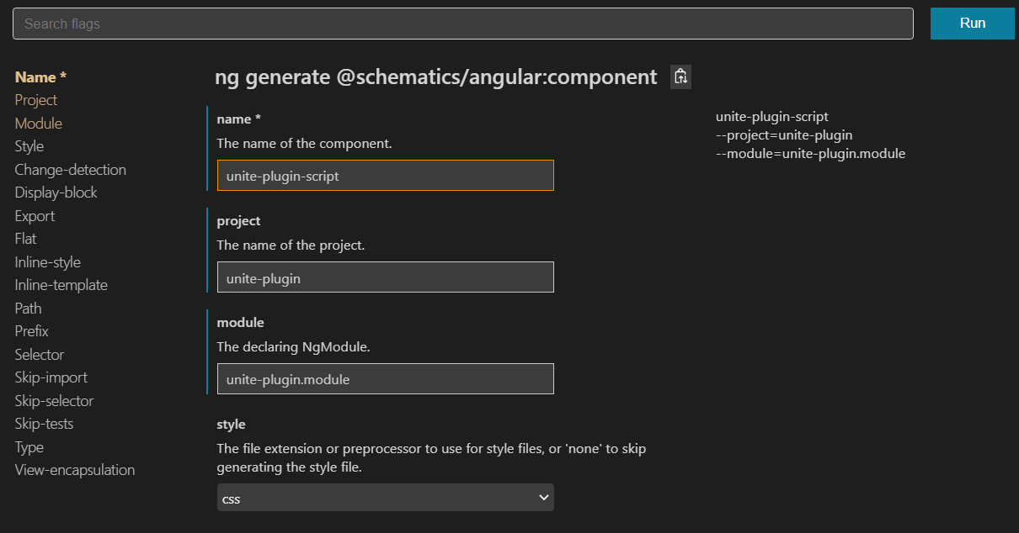

2. Modify unite-plugin.component

unite-plugin.module.ts

- Make sure UnitePluginComponent and UnitePluginScriptComponent are declared in the module AND TileModule and MetaTableModule are imported:

@NgModule({

    declarations: [

        UnitePluginComponent,

        UnitePluginScriptComponent

    ],

    exports: [

        UnitePluginComponent

    ],

    imports: [

        TileModule,

        MatTableModule

    ]

})

unite-plugin.service.ts:

- Import V2Client from our custom Api Server plugin client.

import { V2Client, TypedClient } from 'imx-api-uniteplugin';

'imx-api-uniteplugin' is a client library for calling methods in custom Api Server plugin

- Instantiate V2Client in constructor:

constructor(

private readonly extService: ExtService,

private readonly router: Router,

private readonly appConfig: AppConfigService,

private readonly translationProvider: ImxTranslationProviderService

) {

const schemaProvider = appConfig.client;

this.v2Client = new **V2Client**(appConfig.apiClient, schemaProvider);

this.typedClient = new **TypedClient**(this.v2Client, this.translationProvider);

}

- In the initializer register UnitePluginComponent to appear on the dashboard as a small tile.

public onInit(): void{

this.extService.register('Dashboard-SmallTiles', {instance: **UnitePluginComponent**})

}

- Add new method to retrieve data from a script   
Method portal_uniteplugin_getreportsrolesscript_get is one of the methods in the custom Api Server plugin

**async** userGetReportRolesScript**(**uidPerson**):** Promise**<**any**>** **{**

**try{**

var data **=** **await**   
 **this.**v2Client**.**portal_uniteplugin_getreportsrolesscript_get**(**uidPerson**);**

**return** data**;**

}catch(e) {

console**.**error**(**e**);**

**}**

}

unite-plugin.component.html:

Clicking on the “actionText” will call function doOnClickOperation()

<imx-tile  
 [caption]="caption"  
 [value]="description"  
 [actionText]="actionText"  
 buttonColor="red"  
 size="Addon-Tile"  
 (actionClick)="**doOnClickOperation**()">

</imx-tile>

unite-plugin.component.ts:

- Declarations:

caption**:** string **=** "View Custom Data"

actionText**:** string **=** ""**;**

userId**:** string **=** ""**;**

description**:** string **=** "Logged in user can view a list of his reports with assigned Business Roles"

title**:** string **=** "Reports with assigned Business Roles"

- Constructor:

constructor**(**

**public** requestsService**:** RequestsService**,**

**public** **readonly** sessionService**:** imx_SessionService**,**

**public** unitePluginService**:** UnitePluginService**,**

**private** **readonly** sidesheetService**:** EuiSidesheetService

**)** **{** **}**

- Initialization:

Here we retrieve logged in userId and Username

**async** ngOnInit**():** Promise**<**void**>** **{**

console**.**log**(**"UnitePluginComponent -> onInit"**)**

**this.**userId **=** **(await** **this.**sessionService**.**getSessionState**()).**UserUid

**this.**actionText **=** **(await** **this.**sessionService**.**getSessionState**()).**Username

**}**

- doOnClickOperation():

This function opens a side sheet and passes to it some configuration and the component (UnitedPluginScriptComponent), which will be displayed in that side sheet.

One of the config parameters is “data”. We can pass userId to the UnitedPluginScriptComponent using this parameter.

**public** **async** doOnClickOperation**():** Promise**<void>** **{**

**const** title **=** **this.**title**;**

**const** config**:** EuiSidesheetConfig **=** **{**

title**:** title**,**

width**:** '900px'**,**

headerColour**:** 'green'**,**

data: this.userId,

**};**

**const** sidesheetRef **=** **this.**sidesheetService**.open(**

UnitePluginScriptComponent, config

**);**

**}**

3. Modify united-plugin-script.component

In this component we’ll use [Material Design Components for Angular](https://v14.material.angular.io/components/table/overview) (mat-table)

to display data, returned by the custom Api Server plugin

unite-plugin-script.component.ts:

- Declarations:

Declare columns the mat-table will display (these are attributes of the JSON data)

myDataArray: any;

columnsToDisplay **=** **[**'ManagerCentralAccount'**,** 'FirstName'**,** 'LastName'**,** 'BusinessRole'**,** 'Title'**];**

- Constructor:

See sidesheetdata. User ID from previous component will be passed here.

constructor(

private sidesheetService: EuiSidesheetService,

private sidesheetRef: EuiSidesheetRef,

public unitePluginService: UnitePluginService,

@Inject(EUI_SIDESHEET_DATA) public **sidesheetdata**?: any

) {}

- Initializer:

Retrieve data from unite-plugin.service.ts and store it locally

**async** ngOnInit**():** Promise**<void>** **{**

**const** uidPerson **=** **this.**sidesheetdata

**var** roles **=** **await** **this.**unitePluginService**.**userGetReportRolesScript**(**uidPerson**);**

**this.**myDataArray **=** roles

**}**

unite-plugin-script.component.html:

- Add table with data source, cells with call source, header row and regular row definitions. Remember cloumnsToDisplay from Declarations?

<h1><b>This component displays data retrieved by script</b></h1>

<button mat-button color="warn" (click)='navigateToSqlComponent()'> Got to SQL Component </button>

<table mat-table [dataSource]="myDataArray">

<ng-container matColumnDef="ManagerCentralAccount">

<th mat-header-cell *matHeaderCellDef> Manager Central Account </th>

<td mat-cell *matCellDef="let element"> {{element.ManagerCentralAccount}} </td>

</ng-container>

<ng-container matColumnDef="FirstName">

<th mat-header-cell *matHeaderCellDef> First Name </th>

<td mat-cell *matCellDef="let element"> {{element.FirstName}} </td>

</ng-container>

<ng-container matColumnDef="LastName">

<th mat-header-cell *matHeaderCellDef> Last Name </th>

<td mat-cell *matCellDef="let element"> {{element.LastName}} </td>

</ng-container>

<ng-container matColumnDef="BusinessRole">

<th mat-header-cell *matHeaderCellDef>Business Role</th>

<td mat-cell *matCellDef="let element"> {{element.BusinessRole}} </td>

</ng-container>

<ng-container matColumnDef="Title">

<th mat-header-cell *matHeaderCellDef> Title </th>

<td mat-cell *matCellDef="let element"> {{element.Title}} </td>

</ng-container>

<!--<mat-text-column name="FirstName"></mat-text-column>-->

<tr mat-header-row *matHeaderRowDef="columnsToDisplay"></tr>

<tr mat-row *matRowDef="let myRowData; columns: columnsToDisplay"></tr>

</table>

Debug

1. Start debugging like in Start Debugging Base Plugin Component

Run command npm run build:watch:dynamic unite-plugin to compile and run module in the debug mode.

2. Click on “View Custom Data” tile.   
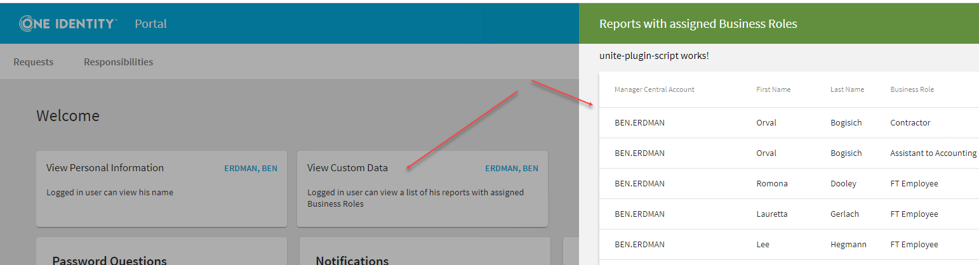

Add component displaying data from predefined SQL

This component will open as a full page in the portal. We need to

use Routes for that (unlike the previous one, which opened in the Sidesheet).

1. Using Nx Console generate a new module “unite-plugin-sql”.

It will be used to display data, returned from an Api Server method (the one that uses Predefined SQL to retrieve data).

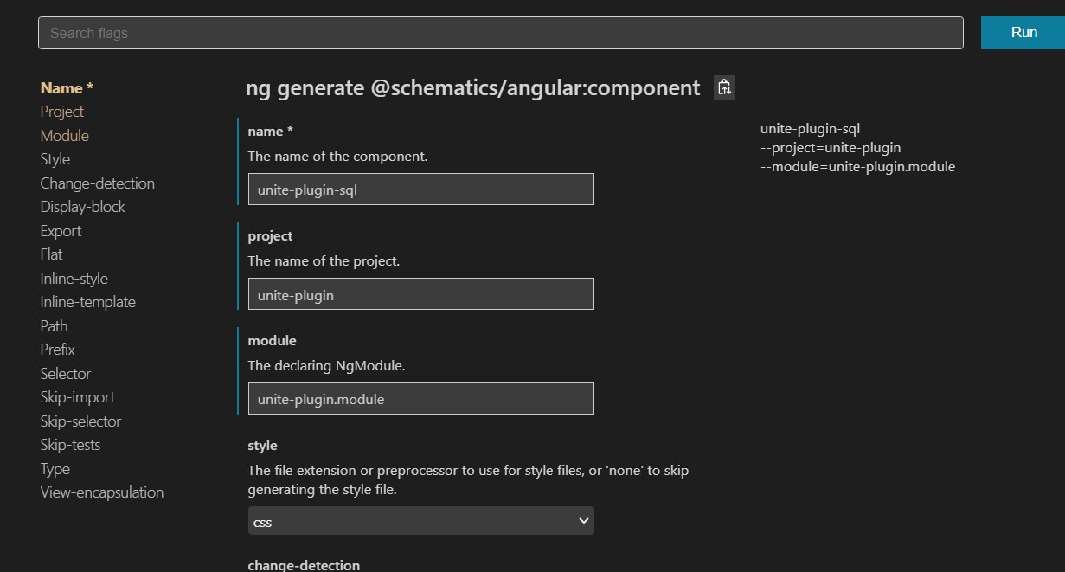

2. Modify unite-plugin.module, unite-plugin.component and

unite-plugin-script.component.

Complete source code will be available in the \UNITE\Chapter Files\7. Add custom plugin calling custom Api Server plugin\unite-plugin\src\lib\unite-plugin-sql folder.

unite-plugin.module.ts

- Add UnitePluginSqlComponent to the declarations

- Declare routes

const routes: Routes = [

    {

      path: 'imx-unite-plugin-sql',

      component: UnitePluginSqlComponent

    }

];

- Change declarations:

@NgModule({

    declarations: [

        UnitePluginComponent,

        UnitePluginScriptComponent,

UnitePluginSqlComponent

    ],

    exports: [

        UnitePluginComponent

    ],

    imports: [

        RouterModule.forChild(routes),

TileModule,

MatTableModule,

DataSourceToolbarModule,

DataTableModule

    ]

})

- Import RouterModule.forChild(routes)

- Pass routes to UnitePluginService in initializer

export class UnitePluginModule {

  constructor(private readonly initializer: UnitePluginService) {

        console.log('In constructor of UnitePluginModule.');

        this.initializer.onInit(routes);

        console.log('UnitePluginModule initialized');

    }

}

unite-plugin.service.ts

- Add parameter routes: Route[] to onInit function and process them

async onInit(routes: Route[]) {

**this.**addRoutes**(**routes**);**

**this.**extService**.**register**(**'Dashboard-SmallTiles'**,** **{**instance**:** UnitePluginComponent**})**

}

addRoutes(routes: Route[]) {

    const config = this.router.config;

    routes.forEach(route => {

      config.unshift(route);

    });

    this.router.resetConfig(config);

 }

Add methods to return data and schema from custom Api Server method which uses Predefined SQL to return data:

async userGetReportRolesSQL(uidPerson): Promise<any> {

try{

var x = await this.**typedClient**.PortalUnitepluginGetreportsrolessql.Get(uidPerson);

return x;

}catch(e) {

console.error(e);

}

}

async userGetReportRolesSQLSchema(): Promise<any> {

try{

var x = await this.**typedClient**.PortalUnitepluginGetreportsrolessql.GetSchema()

return x;

}catch(e) {

console.error(e);

}

}

Please notice that here we use TypedClient to retrieve data instead of V2Client we used for retrieving data from script. These classes are automatically created when .tgz file is generated.

unite-plugin-SCRIPT.component.html

- Add button to the html near the top.

This button will close current side sheet and redirect to the Unite SQL component.

<button mat-button mat-button color="blue" (click)='navigateToSqlComponent()'>

Got to SQL Component </button>

unite-plugin-script.component.ts

- Add router in the constructor

public readonly router: Router,

- Add function to process click event from button above.  
 It closes current sidesheet and redirects to the sql component

async navigateToSqlComponent(): Promise<void>{

    this.sidesheetService.close();

    this.router.navigate(['imx-unite-plugin-sql']);

  }

unite-plugin-SQL.component.ts

- Declarations

myDataArray: any;

public dstSettings: DataSourceToolbarSettings;

userId: string = "";

private readonly busy: EuiLoadingService

displayColumn: any;

public displayedColumns: IClientProperty[];

- Constructor

constructor(

public readonly sessionService: imx_SessionService,

public unitePluginService: UnitePluginService,

private readonly appConfig: AppConfigService,

private readonly router: Router

) { }

- ngOnInit:

* Here we retrieve userID (currently logged in) from session service.
* Retrieve roles from unitePluginService (received in constructor).
* Retrieve schema, which describes data from ApiServer
* Populate an array of Displayed Columns
* Populate class dtsSettings. imx-data-table uses this class to display data.

**async** ngOnInit**():** Promise**<void>** **{**

**this.**userId **=** **(await** **this.**sessionService**.**getSessionState**()).**UserUid

**var** roles **=** **await** **this.**unitePluginService**.**userGetReportRolesSQL**(this.**userId**);**

**var** schema **=** **await** **this.**unitePluginService**.**userGetReportRolesSQLSchema**();**

//---------------------------------------------------------------------------------------

**this.**displayedColumns **=** **[**

schema**.**Columns**.**CentralAccount**,**

schema**.**Columns**.**FirstName**,**

schema**.**Columns**.**LastName**,**

schema**.**Columns**.**Ident_Org**,**

schema**.**Columns**.**Title

**];**

//----------------------------------------------------------------------------------------

**this.**dstSettings **=** **{**

displayedColumns**:** **this.**displayedColumns**,** //

dataSource**:** roles**,**

entitySchema**:** schema**,**

navigationState**:** **{** PageSize**:** 5**,** StartIndex**:**0 **}**

**};**

**}**

- Add method to navigate to the Start Page (Dashboard). This method will be called by the html button.

navigateToStartPage**():void{**

**this.**router**.navigate([this.**appConfig**.**Config**.**routeConfig**.**start**],** **{** queryParams**:** **{}** **});**

**}**

unite-plugin-SQL.component.html

- Add imx-data-table. This table together with imx-data-source use   
 dstSettings (from the component .ts file) to display data

<imx-data-source-toolbar #dst [options]=**"['search']"**

[settings]=**"dstSettings"** data-imx-identifier=**"test-sql-dst"**>

</imx-data-source-toolbar>

<imx-data-table [dst]=**"dst"** [detailViewVisible]=**"true"** mode=**"auto"** [selectable]=**"false"**

[showSelectedItemsMenu]=**"false"**

data-imx-identifier=**"test-sql-datatable"**

noMatchingDataText="#LDS#There are no matching identities.">

</imx-data-table>

- Add a button near the top of the page to redirect to the start page.

<button mat-button mat-button color=**"warn"** (click)=**'navigateToStartPage()'**> **Back to Dashboard** </button>

Debug

1. Start debugging like in Start Debugging Base Plugin Component

Run command npm run build:watch:dynamic unite-plugin to compile and run module in the debug mode.

2. Click on “View Custom Data” tile. See side sheet with data.

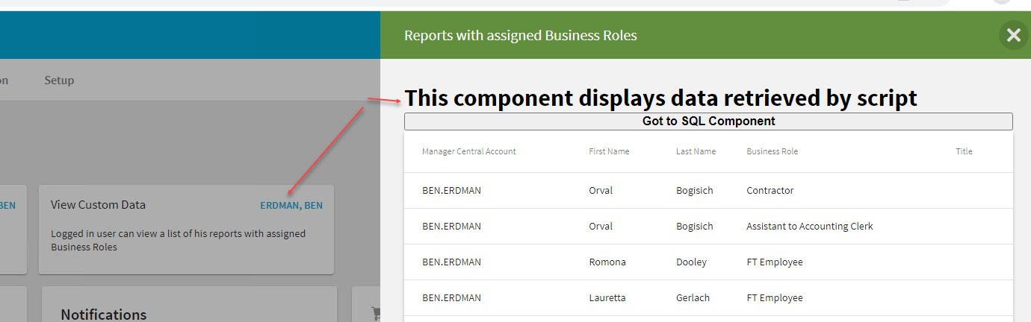

3. Click on “Go to SQL Component”. See side sheet close and browser redirected to the new page. This is the same data, just retrieved in a different way from IM database (script vs Predefined SQL) and displayed in a different table.

Click on “Cack to Dashboard” to be redirected to the start page.

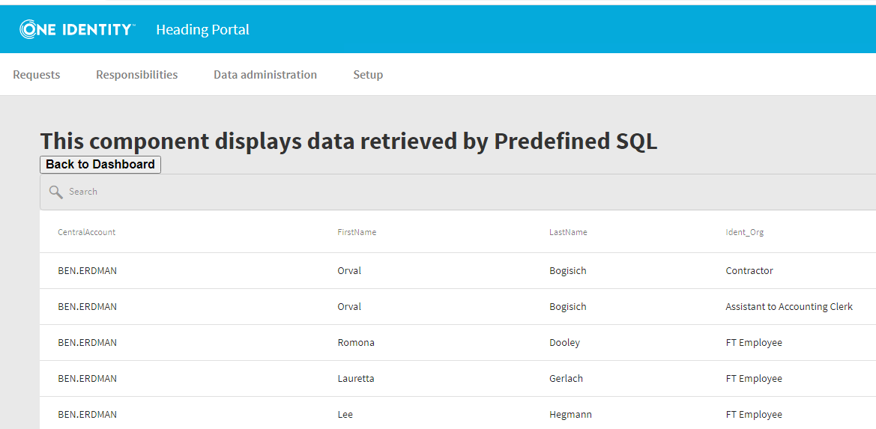

4. Set breakpoints to stop code and view the data, returned from ApiServer

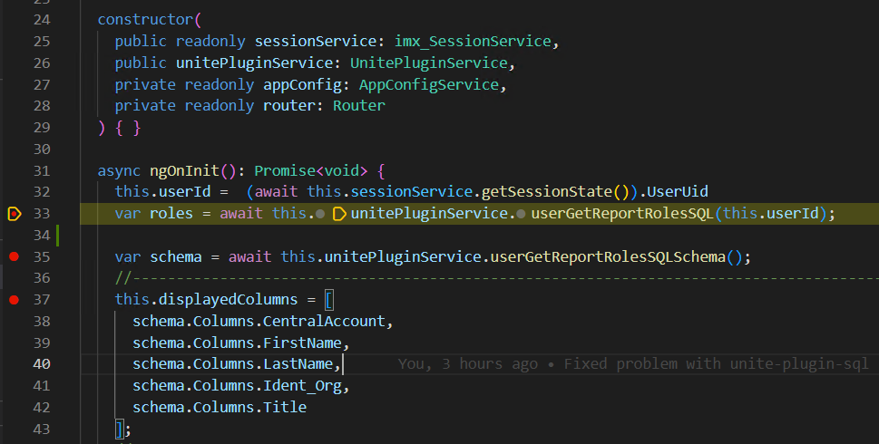

Moving custom modifications to a new release version

Yet to be determined.

Useful Links

[Angular Web site](https://angular.io/)

[General Angular Components](https://material.angular.io/components/categories)

[Angular Components used in Web Portal](https://elemental.dev.oneidentity.com/)

[OIM Web Portal GitHub](https://github.com/OneIdentity/IdentityManager.Imx)

[IM Documentation - Web Portal Development guide](https://support.oneidentity.com/technical-documents/identity-manager/9.1/html5-development-guide)

[IM Documentation - API Development Guide](https://support.oneidentity.com/technical-documents/identity-manager/9.1/api-development-guide)

[Angular Web Development videos from Herwig Abele](https://www.youtube.com/playlist?list=PL242czeZwlAmhFqcLZP6KwlUiro6YWdI9)